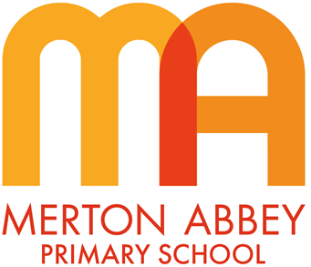
PE Curriculum Map 2025-2026

Our inclusive PE curriculum has been designed around the following school curriculum aims:
 |  |  | 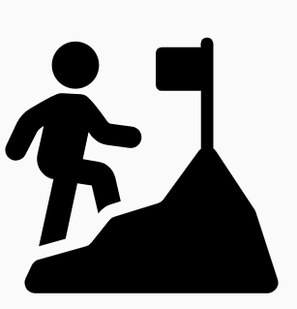 | 
Inspiring joy for learning | Knowledge rich | Reading at the heart | Challenge for all | Holistic approach

Our PE curriculum has been organised around the following 4 key concepts which underpin all of our substantive knowledge:
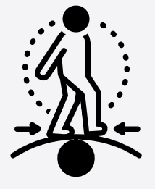 |  |  | 
Children develop competence to excel in a broad range of physical activities. | Children are physically active for sustained periods of time. | Children engage in competitive sports and activities. | Children  lead healthy, active lives.
During the course of our PE curriculum, our children will also develop the following disciplinary knowledge:
 |  | 
Head  (Creativity, understanding and decision making)  Children learn the rules of games and will develop their understanding of strategy. They will progress in their ability to apply the rules and strategies to games independently and collaboratively.  We aim for the children to develop the ability to make quick decisions in different circumstances and to respond to different situations with skill and purpose.  Children will reflect on their performances and the performances of others and suggest improvements in strategy and/or practice. | Heart  (Fair play, leadership, social)  Children learn to distinguish between thinking emotionally and logically in sport. They will learn to win and lose with decorum and will learn the behaviours of a role model.  Children learn specific sporting etiquette as well as general sportsmanship.  Our children will learn how to be leaders on the sports field and be able to use their influence to affect change.  Sport is taught with a positive individual and team ethos in mind, with a focus on encouragement and aspiration. | Hands  (Fitness and physical literacy)  Children learn a broad range of transferable physical skills with a particular focus on education around the importance of physical fitness for a healthy body and a healthy mind.  Children are prepared for success in multiple disciplines and will be able to apply physical skills and fitness in a variety of different scenarios.  Children learn the importance of good technique from a safety and success point of view.  Children also learn to transfer these skills from practice to a competitive environment.

 | Autumn 1 | Autumn 2 | Spring 1 | Spring 2 |  | Summer 1 | Summer 2
EYFS
Session 1 themes | Body Awareness or Movement
Session 2 themes | Stability or Object Control
Year 1
Units of work | Athletics 1  Gymnastics 1 | Games 1  Dance 1 | Athletics 2  Gymnastics 2 | Games 2  Dance 2 |  | Athletics 3  Gymnastics 3 | Games 3  Dance 3
Year 2
Units of work | Athletics 1  Gymnastics 1 | Games 1  Dance 1 | Athletics 2  Gymnastics 2 | Games 2  Dance 2 |  | Athletics 3  Gymnastics 3 | Games 3  Dance 3
Year 3
Units of work | Invasion Games – Tag Rugby 1  (MSSP coach)  Gymnastics 1 (CT) | Athletics 1 (MSSP coach)  Dance 1 (CT) | Invasion Games - Football 1 (MSSP coach)  Gymnastics 2 (CT) | Invasion Games –  Hockey 1 (MSSP coach)  Dance 2 (CT) | N & W Games – Tennis 1 (MSSP coach)  Gymnastics 3 (CT) |  |  | Athletics 2 (MSSP coach)  OAA 1 (CT)
Year 4
Units of work | Invasion Games – Tag Rugby 1 (MSSP coach)  Gymnastics 1 (CT) | Athletics 1(MSSP coach)  Dance 1 (CT) | Invasion Games –  Football (MSSP coach)  Gymnastics 2 (CT) | Invasion Games –  Hockey 1 (MSSP coach)  Dance 2 (CT) | N & W Games -  Tennis 1 (MSSP coach)  Gymnastics 3 (CT) |  |  | Athletics 2 (MSSP coach)  OAA 1 (CT)
Year 5
Units of work | Athletics 1 (MSSP coach)  Gymnastics 1 (CT) | Sports Leadership (MSSP coach)  Dance 1 (CT) | Invasion Games –  Tag Rugby 1 (MSSP coach)  Gymnastics 2 (CT) | Invasion Games –  Hockey 1 (MSSP coach)  Dance 2 (CT) | N & W Games -  Tennis 1 (MSSP coach)  Swimming  (2-weeks (core lessons)) |  |  | Athletics 2 (MSSP coach)  Swimming  (2-week top-up)
Year 6
Units of work | Athletics 1 (MSSP coach)  Swimming  (2-weeks top-up | Invasion Games –  Football 1 (MSSP coach)  Swimming  (2-weeks top-up | Invasion Games –  Tag Rugby 1 (MSSP coach) Gymnastics 1 (CT) | Invasion Games –  Hockey 1 (MSSP coach)  Dance 1 (CT) | N & W Games -  Tennis 1 (MSSP coach)  Gymnastics 2 (CT) |  |  | Athletics 2 (MSSP coach)  OAA 1 (CT)

