

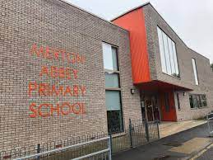
Year 3 Autumn
Newsletter
Upcoming events:

Meet the Teacher
(3:45pm or 4:15pm*)
Wednesday 17th September
*please attend one

Harvest Assembly (9am or 3pm*)
Tuesday 7th October
*please attend one

Trips:
The Colliers Wood Library
Wimbledon Village
Deen City Farm Nativity- TBC

Dear Nelson Class Parents and Carers,
Welcome back! We hope you had a restful Summer break and are looking forward to a brand-new year.

This newsletter will inform you on what your child will learn in the upcoming weeks in Autumn term.

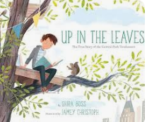
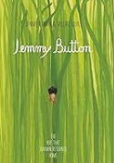

Core subjects: In Writing, the focus books are Black Dog, Jemmy Button and Up in the Leaves. The children will use these high-quality texts to learn how to write narratives, biographies and diary entries.

In Maths, children will learn Place Value within 1000, Addition and Subtraction, and Multiplication and Division.

In Science, Skeletons, muscles and nutrition will be taught in Biology, and Rocks in Chemistry.

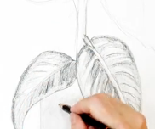
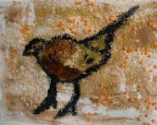
In other subjects, children will learn about Programming by using Scratch in Computing, Respectful Religion and worldviews in R.E., How regions vary in the UK in Geography, Developing drawing skills and Prehistoric Art in Art and Design, The Zones of Regulation in PSHE, and Months of the year, Age and Pets in French.

P.E. sessions for Nelson class are on Monday and Wednesday. Please ensure your child comes to school on these days wearing the correct P.E. kit, which they will be wearing for the whole day. This must include a change of trainers or plimsolls, as P.E. lessons will be taught outside whenever possible. An item of clothing with the school logo must be worn when coming to and from school, such as a school jumper or cardigan.

Homework will be handed out every Friday and should be returned by the following Wednesday at the latest.
Nelson class will have their Spelling test every Friday. Spelling will be given to them every Friday.

If you have any questions, please come in and see us!
Yours sincerely
The Year 3 team

Mrs Brown (Teacher), Mrs Murphy (Teaching Assistant) and Miss Aga (Learning Support Assistant).

