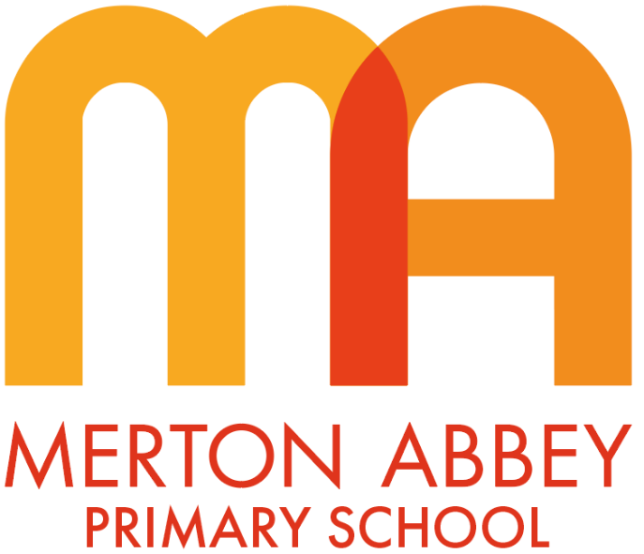

Curriculum policy
This policy will be reviewed in full on a two yearly basis.
This policy was reviewed and updated in September 2024
Next review date: September 2026
This policy is reviewed by the Teaching and Learning committee.

Intent (what is meant to be learnt and what do we aspire for our children)
Our curriculum has been designed using the following principles:

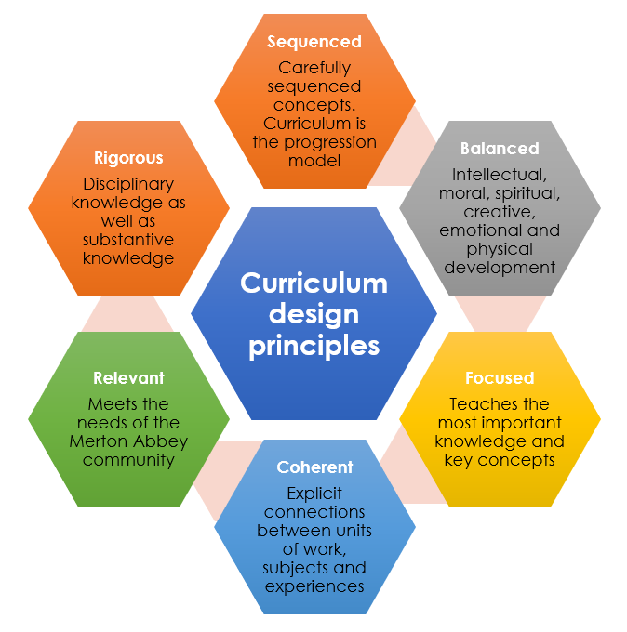
Following discussions with key stakeholders including staff, children and families, we agreed on the following curriculum principles:

- Knowledge rich
Knowledge is an essential social construct upon which our learners can be provided access to a wealth of opportunities, make well-informed decisions and begin to shape their own personalities - after all, ‘knowledge is power’. We aim to ensure that our pupils have the necessary substantive knowledge (the knowledge produced by an academic subject) and disciplinary knowledge (understanding how substantive knowledge is established and continues to be developed and revised) to engage in their worlds in a meaningful way, while navigating a diverse range of contexts and challenges with confidence. We recognise subject disciplines and how they are unique.
The Merton Abbey Curriculum poses driver questions, encouraging our pupils to develop a natural curiosity and to form their own, well considered, lines of enquiry. With the belief that learning can act as a catalyst for further learning, our aim is for pupils to continually build upon their individual starting points while making the necessary connections in content that will piece their learning together. This coherence is achieved through identifying substantive and disciplinary concepts which are developed throughout units of work e.g. Power, empire and democracy in history.

- Inspiring joy for learning
At Merton Abbey we are mindful that for our pupils to excel so our curriculum offer must be one that both engages and inspires them daily. We want our pupils to become immersed in our broad and balanced curriculum with a sense of fascination, awe and wonder and for our teachers to deliver the curriculum in a similar vein. Pupils should feel compelled to share their discoveries with others, speak enthusiastically about the new knowledge they have gained and conduct their own independent research and activities to further enhance their learning. Throughout the design and evolution process, pupils and teachers are given ownership of the curriculum, taught with passion and determination, and to spark and feed curiosities from all parties.

- A holistic approach
In designing the Merton Abbey Curriculum, it has been crucial to place our pupils at the heart of the process. Pupils are offered a broad range of rich, real-life learning experiences, each offering their own invaluable progression of knowledge and skills.
We also believe passionately that the education we provide our pupils should not be constrained to academics alone. We want to produce pupils who are not only academically secure but who are compassionate, empathetic, resilient and able to navigate their social relationships with others confidently and therefore flourish. We aim therefore to expose our pupils to a broader range of social contexts and experiences in order to develop a sense of their own identity and pride in both themselves and their school. We also aim for our children to play an active role in the local community through our visits to Trellis House and engagement with the High Path regeneration and for our children to develop their skills in the creative and expressive arts through our links with Merton Music Foundation, the Polka theatre and ARTIS.
We seek opportunities for pupils to participate as a team member in sporting events, perform as part of a choir/band in concerts, visit places of specific interest and experience different career paths – amongst many others. Furthermore, our curriculum ensures exploration of key virtues and values through the taught curriculum and caught through experiences, key reading texts and through modelling from our teachers and support staff. In this way, our pupils don’t just leave us with academic credentials but a strong social identity and virtues that will stand them in good stead for the rest of their lives.

- Challenge for all
Our curriculum is designed to be progressively more challenging as children move through the school. Each year group has clearly identified curriculum related expectations which set out the substantive and disciplinary knowledge which expect the children to master. Progression documents for each subject ensure that this knowledge becomes more challenging. We also design our lessons to ensure that children engage in cognitively challenging discussion and thought through the use of thinking questions.

- Reading at the heart
At Merton Abbey we believe that reading is a powerful force for learning as a whole and we embed reading in our curriculum in the following 4 ways; Firstly, we aim to develop a culture of reading for pleasure through exposing children to high-quality literature in our reading and writing lessons. We also use reading as a disciplinary tool for example in history, children read sources of evidence to extract information but also to question and interrogate the sources for contradictions and biases. We also use reading as a way of developing children’s cultural literacy and to develop their vocabulary. Finally, we use reading to develop emotional literacy. Our use of high-quality texts helps children to identify characters’ feelings and emotions and to discuss the virtues which they demonstrate e.g. honesty and integrity.

Knowledge and concepts
Substantive and disciplinary knowledge
Our curriculum is knowledge and vocabulary rich allowing children to develop their understanding of abstract substantive and disciplinary concepts as they move through school.
Substantive knowledge is the knowledge produced by any specific academic subject. It is the knowledge we intend our children to learn from their unit of work. For example, in science, it might be to understand how sounds are made.
Disciplinary knowledge is the understanding of how that knowledge was formed, how it continues to be formed and a general understanding of how that subject operates. In history, this could be how we gather information from historical sources.
Our curriculum design ensures that children know more and remember more (sticky knowledge) and therefore form ever wider and deeper schemas.

Core concepts
A core aim of our curriculum is not simply knowing the facts; it is having a storehouse of knowledge that is powerful and later contributes to helping young people become skilful historians, scientists etc.
Concepts provide the schema through which meaning is made and connections are formed. They reach back into the past: where have we met this idea before? And they stretch into the future: how can we use this new information? Concepts help us to develop the intellectual architecture for meaning and for strengthening memory over time. Concepts have a powerful effect on learning and we believe that identifying the big ideas helps pupils to make sense of what they are taught. Concepts need to be the driver for the learning.
For example, in history we have 3 key substantive concepts that we aim to develop through the school. These vertical core concepts provide both a concrete lens through which to study and contextualise history, as well as a gradual, deep understanding of complex, abstract ideas.
We also aim to give our children a grounding in core disciplinary knowledge, and the ability to approach challenging enquiry questions.

Subject Specific Vocabulary
Our curriculum prioritises the development and reinforcement of subject-specific vocabulary, ensuring that all pupils acquire a secure understanding of key terms and concepts. By embedding vocabulary instruction across lessons, we aim to close gaps in knowledge and support students in retaining and applying their learning over time, fostering deeper understanding and academic success.

Implementation (how we teach our curriculum)
The strength of the Merton Abbey Curriculum relies heavily on the investment and belief of all stakeholders in the five key aims that underlie the curriculum intent.
Where teachers, pupils and parents alike feel full ownership of the curriculum offer, implementation of the curriculum becomes a collaborative effort; opportunities for learning are enhanced and pupils become fully engaged and immersed in a culture of learning and development. They view every moment, of every day, as an opportunity for the taking and the next step in their journey to greatness.

Communicating Our Intent
It is for this reason that, strategically planned CPD is delivered to ensure all staff are aligned with the curriculum intent, making adaptations through consultation with teachers and supporting teachers in delivering the curriculum with clarity and passion. Parents/carers and pupils are provided the opportunity to reflect on their current experiences at prominent points throughout the year, providing feedback that will aid us to further refine and strengthen our offer. Additionally, parents/carers are invited to engage with individual subject content to support their child’s learning through middle leader-lead workshops and curriculum events.

A Consistent Approach
It is our belief that by establishing a consistent approach in the delivery of the Merton Abbey curriculum, we will be able to ensure that there is no evident provision gap between classes, year groups and cohorts. Middle leaders therefore play a crucial role in the implementation of the curriculum. They devise progression maps for their area of responsibility, and use these to monitor planning and provision across the school, ensuring all pupils have access to a progressive and challenging curriculum offer. They work to define what great practice looks like in their area of the curriculum, and refine explicit models for delivery in their own teaching practice, confidently drawing upon these to model and team teach best practice for colleagues.
Through learning walks, planning and scrutiny of pupil outcomes, leader’s quality assure the delivery of the curriculum and identify gaps in teaching practice, feeding into a progressive programme of CPD to target particular development needs. A supportive coaching programme is in place to target individual development goals, providing teachers with opportunities to develop their own practice with the curriculum offer in mind.

Impact
The impact of the Merton Abbey Curriculum is continually monitored and reviewed and, where necessary, adaptations are made to ensure it continues to provide a high standard of education while remaining reflective of our pupils’ interests and needs. If we are to achieve our intent for each and every pupil, we should ask ourselves the following questions:

Develop children’s powerful knowledge
- Do our pupils express their knowledge around a subject with confidence, and is this replicated in their outcomes?
- Can our pupils apply their knowledge in a range of different contexts and within changing perimeters?
- Do our pupils feel confident to draw upon their learning outside of the classroom?
- Do our pupils form their own lines of enquiry when scaffolds are removed or reduced?
- Are pupils able recall taught knowledge and replicate taught skills with the same confidence further down the line?

Inspire joy for learning
- Do our pupils look forward to coming to school every day, and what motivates them to do so?
- Do our pupils actively engage in lessons and what motivates them in doing so?
- Do the children have regular opportunities for first hand experiences un and out of the classroom?
- Are our parents confident in engaging with the curriculum and encouraging their pupils to achieve great outcomes?
- Do parents and pupils speak enthusiastically about the curriculum offer and the impact on their education?

Develop the whole child
- Do all of our pupils have the opportunity to flourish in at least one area of the curriculum?
- Can pupils express their passions, goals, strengths and areas of development with confidence?
- Are our pupils able to express their aspirations, and do they make the necessary links with their current education?
- Do our pupils make the necessary links in order to thrive socially and face challenges in the future?
- Do our pupils communicate confidently and eloquently within society, both written and verbally?
- Do our pupils demonstrate an understanding of how they can contribute positively to the wider community?
- Do our pupils demonstrate a sense of identity, belonging and responsibility?

Challenge for all
- Do our pupils feel that they are challenged within their lessons?
- Do our pupils report that they asked to think hard about their learning during lessons through the consistent use of thinking questions?
- Do the majority of pupils meet the progressively more challenging curriculum related expectations?
- Do our pupils feel that they are improving in particular subjects?
- Are children with SEND accessing the broad and balanced curriculum and scaffolded to achieve well?

Reading at the heart
- Do our pupils have a passion for reading?
- Can our pupils identify their favourite authors and discuss favourite genres?
- Do the majority of lessons incorporate elements of reading and use it as a disciplinary tool?
- Do our children achieve well in reading assessments across the school?

Impact Measures
The impact of the curriculum can be measured further through analysis of the following measures: Quantitative results: At end of key stages / planned assessment points throughout the year. Strong academic attainment and progress will be a natural by-product of the broad and rich curriculum that we provide, where a consistent approach is adopted and gaps in provision are closed.

Qualitative results: A planned cycle of surveys and reflective opportunities for pupils, parents and teachers will highlight successes in the curriculum and identify areas of development and refinement. Any challenges that arise will be addressed in order to strengthen the curriculum offer and implementation.

Roles and responsibilities

The governing board
The governing board will monitor the effectiveness of this policy and hold the headteacher and leadership team to account for its implementation.
The governing board will also ensure that:
- A robust framework is in place for setting curriculum priorities and aspirational targets
- Enough teaching time is provided for pupils to cover the National Curriculum and other statutory requirements
- Proper provision is made for pupils with different abilities and needs, including children with special educational needs (SEN)
- The school implements the relevant statutory assessment arrangements
- It participates actively in decision-making about the breadth and balance of the curriculum
- It fulfils its role in processes to disapply pupils from all or part of the National Curriculum, where appropriate, and in any subsequent appeals
Headteacher
The headteacher is responsible for ensuring that this policy is adhered to, and that:
- All required elements of the curriculum, and those subjects which the school chooses to offer, have aims and objectives which reflect the aims of the school and indicate how the needs of individual pupils will be met
- The amount of time provided for teaching the required elements of the curriculum is adequate and is reviewed by the governing board
- Where appropriate, the individual needs of some pupils are met by permanent or temporary disapplication from all or part of the National Curriculum
- They manage requests to withdraw children from curriculum subjects, where appropriate
- The school’s procedures for assessment meet all legal requirements
- The governing board is fully involved in decision-making processes that relate to the breadth and balance of the curriculum
- The governing board is advised on whole-school targets in order to make informed decisions
- Proper provision is in place for pupils with different abilities and needs, including children with SEN
Curriculum lead
The curriculum lead will ensure that:
- The curriculum is well sequenced and coherent and support colleagues with their curriculum delivery
- The intended curriculum is delivered according to the curriculum policy
- Each subject is well sequenced with clear progression documents indicating progress in substantive and disciplinary knowledge
- Subject leads are clear about their role and have the necessary skills to be able to effectively lead their subjects
- Children are ‘knowing more and remembering more’ through the use of Quality Assurance strategies such as Pupil Book Study.

Subject leads
Subject leads will ensure that:
- Their curriculum is well sequenced and coherent and be able to answer key questions such as ‘Why this?’ and ‘Why now?’
- Their subject meets the aims of the whole school curriculum
- There is a clear vision and intent for their subject
- Support colleagues with the subject knowledge and delivery of their subject
- Their subject has a clear progression document which indicate progress in substantive and disciplinary knowledge
- Subject-specific vocabulary for each topic is identified and follows a clear progression. Teachers explicitly teach this vocabulary, and its effectiveness is evident through picture-building activities.
- Regularly check-in with their subject to build a picture around curriculum implementation
- Children, including those with SEN, keep up with the challenging curriculum design

Inclusion
Teachers set high expectations for all pupils. They will use appropriate assessment to set ambitious targets and plan challenging work for all groups, including:
- Pupils with high prior attainment
- Pupils with low prior attainment
- Pupils from disadvantaged backgrounds
- Pupils with SEND
- Pupils with English as an additional language (EAL)
Teachers will plan lessons so that pupils with SEN and/or disabilities can study every National Curriculum subject, wherever possible, and ensure that there are no barriers to every pupil achieving.
Teachers will also take account of the needs of pupils whose first language is not English. Lessons will be planned so that teaching opportunities help pupils to develop their English, and to support pupils to take part in all subjects.
Further information can be found in our statement of equality information and objectives, and in our SEN policy and information report.

Links with other policies: Teaching and Learning policy, Assessment policy, EYFS policy, SEND policy and information report, Equality information and objectives

