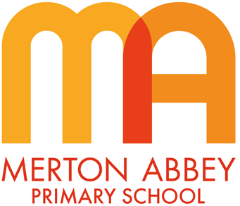
Geography Curriculum Map 2025-2026
Our inclusive geography curriculum has been designed around the following school curriculum aims:
 |  |  | 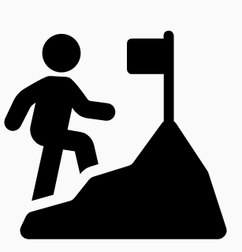 | 
Inspiring joy for learning | Knowledge rich | Reading at the heart | Challenge for all | Holistic approach

Our geography curriculum has been organised around the following 4 key concepts which underpin all of our substantive knowledge:
- ‘Place’ What is this place called?’ What is it like?’ What kind of features does it have? (Human and physical) What do people do here? How do I feel about it? How does it compare to other places?
- ‘Space’ Where is this place? How does it connect other places? How can it be mapped? What is unique about its location?
- ‘Scale’ How does my view of this place change when I zoom in or out? How and why are places connected? What is the local/global story?
- ‘Sustainability’ How and why is this place changing? What are people doing to make it sustainable? How can we help?

During the course of our geography curriculum, our children will also develop the following disciplinary knowledge:
 | 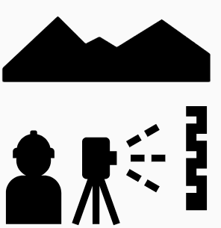 | 
Mapping | Fieldwork enquiry | Enquiry and vocabulary

 | Autumn 1 | Autumn 2 | Spring 1 | Spring 2 |  | Summer 1 | Summer 2
EYFS theme | Me and my family | Celebrations | Food | Plants and growth |  | Animals | South Wimbledon (people who help us)
Year 1
Unit of work | What is special about our school? |  | What is the UK like? (Barnaby Bear) |  |  |  | How is the seaside different to London?
Key concepts | Geographical skills  Fieldwork enquiry  Using examples and vocabulary |  | Geographical skills  Using examples and vocabulary |  |  |  | Geographical skills  Fieldwork enquiry  Using examples and vocabulary
Year 2
Unit of work | Where are the places in the world? (Barnaby Bear) |  |  | What is our street like? |  |  | How is Kenya the same and different to the UK?
Key concepts | Geographical skills  Using examples and vocabulary |  |  | Geographical skills  Fieldwork enquiry  Using examples and vocabulary |  |  | Geographical skills  Using examples and vocabulary  Sustainability
Year 3
Unit of work | How do regions in the UK vary? |  |  | Where are mountains and volcanoes located in the world? | What is London like?
Key concepts | Geographical skills  Using examples and vocabulary |  |  | Geographical skills  Using examples and vocabulary | Geographical skills  Fieldwork enquiry  Using examples and vocabulary  Sustainability
Year 4
Unit of work | What is our town like? |  | How does La Plagne compare to London? |  | How does water affect our lives?
Key concepts | Geographical skills  Fieldwork enquiry  Using examples and vocabulary  Sustainability |  | Geographical skills  Using examples and vocabulary |  | Geographical skills  Fieldwork enquiry  Using examples and vocabulary  Sustainability
Year 5
Unit of work |  | What are Biomes and climate zones? |  | Where are Rivers located around the world? | What are rainforest biomes like?
Key concepts |  | Geographical skills  Using examples and vocabulary |  | Geographical skills  Fieldwork enquiry  Using examples and vocabulary | Geographical skills  Using examples and vocabulary
Year 6
Unit of work |  | What is world trade and what are its effects? |  | Why are the lines of latitude and longitude so important? |  |  |  | How do we map the world?
Key concepts |  | Geographical skills  Using examples and vocabulary  Sustainability |  | Geographical skills  Using examples and vocabulary |  |  |  | Geographical skills  Fieldwork enquiry  Using examples and vocabulary

