
Merton Abbey Primary School
Reading Policy

This policy will be reviewed in full on an annual basis.
This policy was reviewed and updated in December 2025
Next review date: November 2027
Member of staff responsible for monitoring and reviewing the policy: Philip Lawlor

Intent (what is meant to be learnt and what do we aspire for our children)

Rationale for Reading
“Reading is the gateway skill that makes all other learning possible”. Barack Obama

“The more that you read, the more things you will know. The more that you learn, the more places you’ll go”. Dr Seuss

At Merton Abbey, we value reading as a key life skill and we are dedicated to enabling our pupils to become lifelong readers. We aspire to ensure our pupils establish an appreciation and genuine love of reading across all genres. We believe reading opens a new world for children and gives them an opportunity to explore new ideas, visit new places, meet new characters and develop a better understanding of other cultures. Reading feeds pupil’s imagination and opens up a treasure-house of wonder and joy for curious minds. At Merton Abbey, children are exposed to high quality literature, regardless of their ability. We provide language-rich classroom environments and a curriculum where children are exposed to, and actively engage with, high quality language in varying forms in a meaningful, deliberate and engaging way. Through building children’s vocabulary, it gives them the word power they need to become successful speakers and writers as well as confident readers.

Aims (from the National Curriculum)
Our curriculum for reading aims to ensure that all pupils:

- read easily, fluently and with good understanding
- develop the habit of reading widely and often, for both pleasure and information
- acquire a wide vocabulary, an understanding of grammar and knowledge of linguistic conventions for reading, writing and spoken language
- appreciate our rich and varied literary heritage

Implementation (how we teach our curriculum)

In years two to six, children engage and participate in daily whole class reading sessions.

Agreed principles for the teaching of reading:
- Develop a love of reading;
- Use of high-quality texts;
- Focus on improving children's fluency as this has a significant impact on comprehension ability;
- Teacher modelling of reading will be a regular feature of the sessions;
- Vocabulary will be taught before reading a new chapter/text;
- Repeated reading of extracts and texts will be a regular feature of the sessions;
- Reading comprehension strategies will be modelled- I do, we do, you do.

Whole class reading structure:
Monday:
- Introduction/discussion on key vocabulary required before reading the chapter/text/extract. Links should be made to similar words and prefixes and suffixes etc. For most words the children can just be told the meaning and a sentence using the word in context but for some word’s children could be asked to use their knowledge of words to work out the meaning. Alternatively, children could be given 3 possible meanings and have to work out the correct meaning.
- Teacher model reads the text. This should be a contiguous read: teachers read a passage with a minimum of interruptions or stoppages. The idea is to experience the text as a whole, to glimpse its broad context; to hear its voice.
- There could be time for initial discussions following the model read.

Tuesday and Wednesday:
- The main focus should be on repeated reading of the text by the children, or teacher if it is a ‘close read’ or ‘echo read’, using a range of approaches:
- Independent reading: children reading aloud independently
- Paired reading: reading in pairs, changing after each paragraph or page
- Group reading: reading in random order in small groups, changing after each paragraph
- Choral reading: teacher and children read the same piece simultaneously
- Echo reading: teacher models a paragraph or chunk of text which the children echo back with the same expression and intonation used by the teacher.
- Control the game: Whole class reading aloud controlled by the teacher. Involves switching between teacher modelling and individuals/pairs/groups reading loud for a short section.
- Another focus should be on reading domain 2b-retrieval. These sessions should be interactive with lots of opportunities to develop children’s oracy skills.

Thursday
- The focus should be on developing other skills particularly reading domain 2d: Inference.
- Children will need to be explicitly taught how to answer inference questions (I do, We do, You do) and children should have the opportunity to record answers which could be discussed at the end of the lesson. Other domains will also need to be addressed.
- Children could also develop drama skills for example through hot-seating key characters.

Friday
There are a range of options for Fridays depending on the needs of your class.
- Drop Everything and Read while teachers and TA’s focus on hearing key 1:1 reading.
- Comprehension practice using unfamiliar texts: see Schofield and Sims books.
- Continuing discussing questions from the previous day.

Impact
As we believe reading is key to all learning, the impact of our reading curriculum goes beyond the result of statutory assessments. Children have the opportunity to enter the wide and varied magical worlds that reading opens up to them. As they develop their own interest in books, a deep love of literature across a range of genres, cultures and styles is enhanced.

By the time children leave Merton Abbey, they are fluent, competent readers who can recommend books to their peers, have a thirst for reading a range of genres including poetry, and participate in discussions about books, including evaluating an author’s use of language and the impact this can have on the reader. They can also read books to enhance their knowledge and understanding of all subjects on the curriculum, and communicate their research to a wider audience.

Reading is assessed in the following ways:

Statutory Assessments
- Year 1: Children take part in the Phonics Screening check.
- Year 6: Children are formally assessed in Reading as part of the end of Key Stage 2 SATs.

In School Assessments
Children in Years 1 to 6 undertake termly assessments using the NTS assessments. Progress is measured using standardised scores.

Informal assessments
Teachers continuously assess children’s attainment and progress during whole class reading sessions.

Appendix 1: Useful strategies for Whole Class Reading

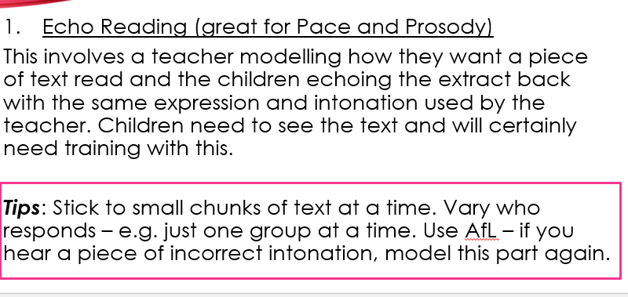
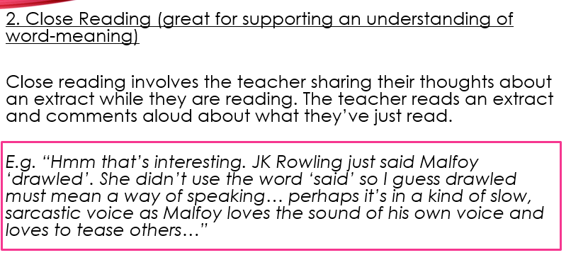
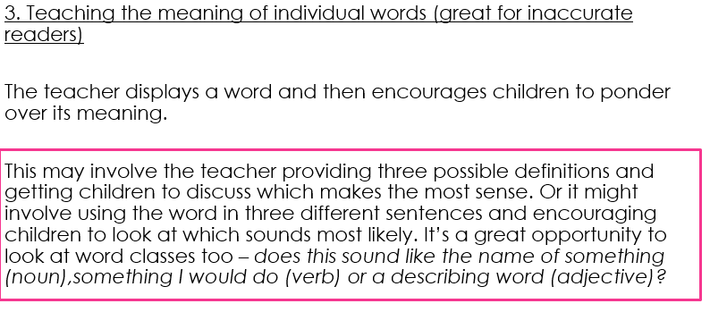
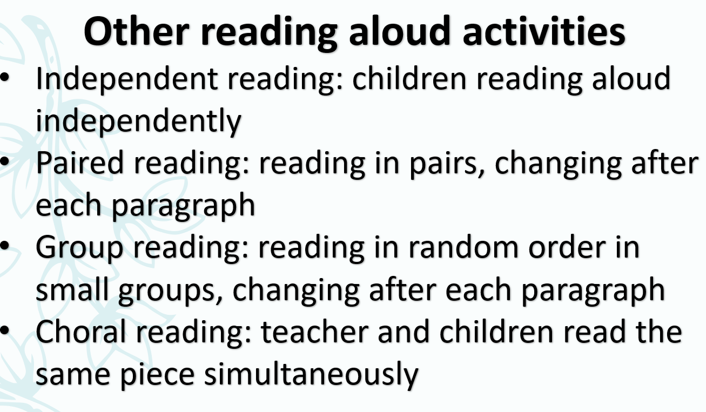

Control the game: Whole class reading aloud controlled by the teacher. Involves switching between teacher modelling and individuals/pairs/groups reading loud for a short section.
Key points to consider:
- Keep durations short-this stops children from tuning out.
- Consider the individuals within the class when asking children to read aloud.
- Keep the identity of the next reader unpredictable.
Keep transitions brief: ‘Continue please

Appendix 2: Planning Format

All planning should be recorded on the agreed planning format. Planning should briefly indicate activities, key vocabulary and questions.

Text: |  |  | Date: |  | Week:
 | Monday | Tuesday | Wednesday | Thursday |  | Friday
Activities:
2a: Give/ explain the meaning of words in context
2b: Retrieve and record information/ identify key details from fiction
2d: Make inferences from the text/ explain and justify inferences with evidence from the text
2e:predict what might happen from details stated and implied

