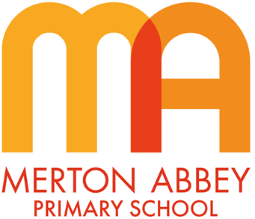
Reading Curriculum Map 2025/26
Our inclusive reading curriculum has been designed around the following aims:
 | 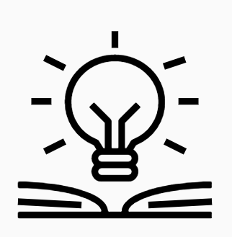 |  | 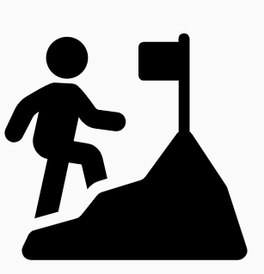 | 
Inspiring joy for learning | Knowledge rich | Reading at the heart | Challenge for all | Holistic approach

 |  | Term 1 | Term 2 | Term 3 | Term 4 | Term 5 | Term 6
Reception and  Year 1 | Guided Reading | Application of Phonics to Reading  Throughout Reception, children will read three times per week in a guided reading group. This will give children the opportunity to apply the phonics they have learnt by reading fully decodable books. The phonic progression in these books match the progression of Little Wandle Letters and Sounds Revised.
Year 2 | Whole Class Reading Text | 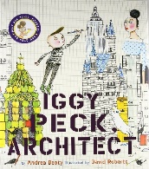  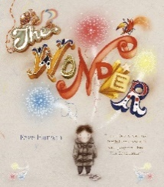  Fiction  Non-Fiction  Comprehension Ninja   | Fiction and Poetry  Comprehension Ninja  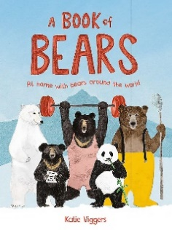  Non-Fiction | 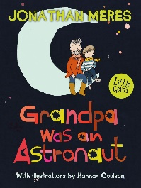  Fiction  Poetry  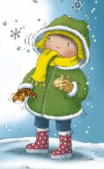  Winter Parcel | 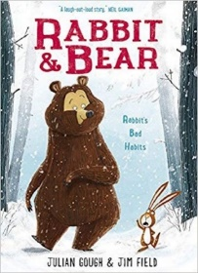  Fiction  Non-Fiction  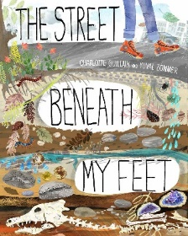 | 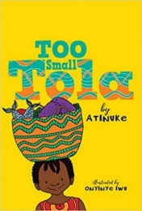  Fiction  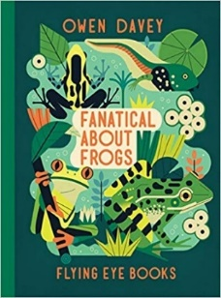  Non-Fiction | 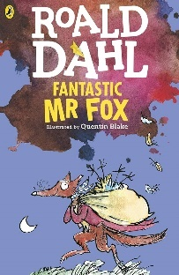  Fiction
Year 3 | Whole Class Reading Text | 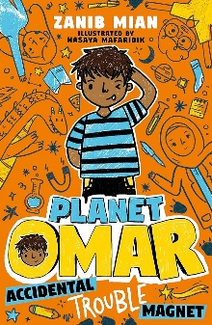  Fiction | 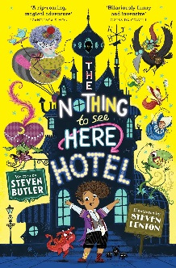  Fiction | Egyptian Myth  TBC  Non-fiction  Selection of Ancient Egypt non-fiction book | 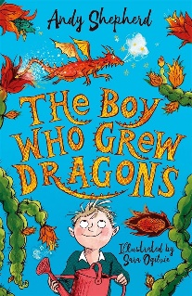  Fiction | Poetry  Selection of different poems | 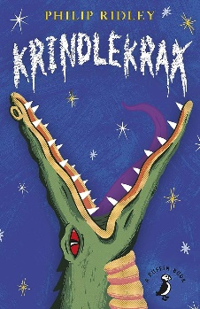  Fiction
Year 4 | Whole Class Reading Text | 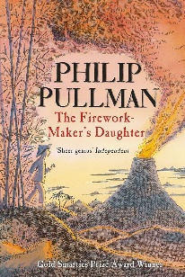  Fiction | 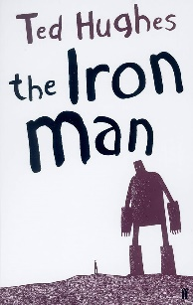  Fiction  Poetry  The Coming of the Iron Man | 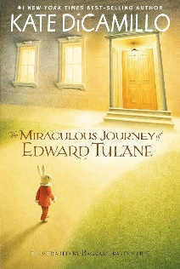  Fiction | 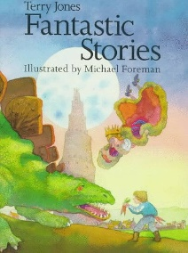  Fiction: Short Stories  Playscripts | 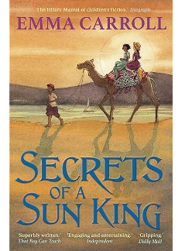  Fiction | 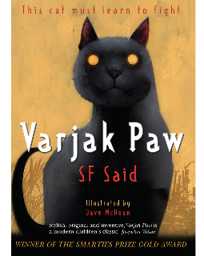  Fiction
Year 5 | Whole Class Reading Text | 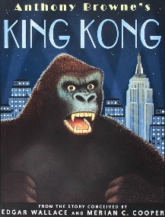  Fiction  Non-Fiction  Information texts about gorillas | 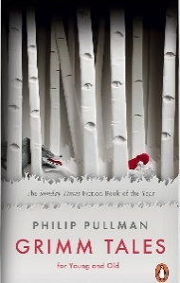  Fiction / Short Stories | 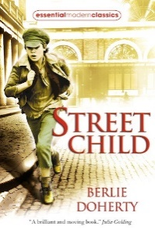  Fiction | 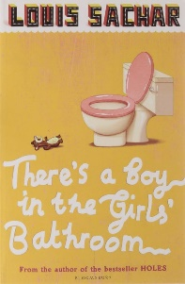  Fiction | 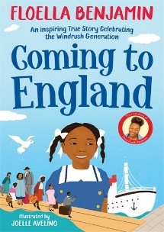  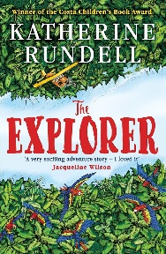  Fiction Autobiography  Poetry  Selection of different poems
Year 6 | Whole Class Reading Text | 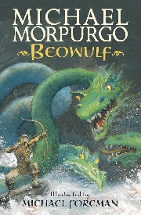  Epic Poetry  Non-Fiction  Non-fiction texts on the Anglo-Saxons | 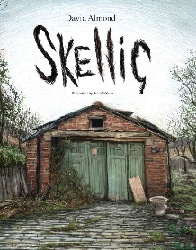  Fiction | 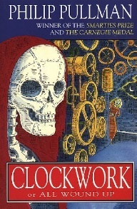  Fiction | 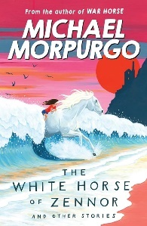  Fiction: Short Stories | 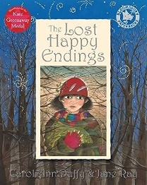  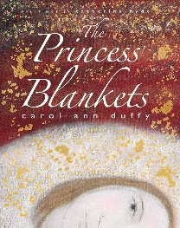  Fiction | 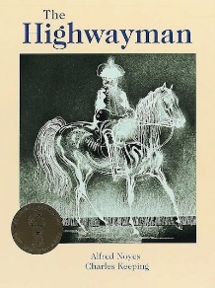  Poetry  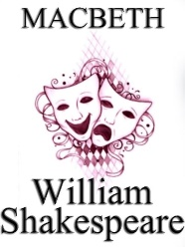  Playscript

