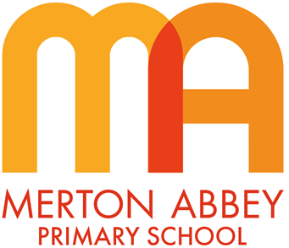
Curriculum Map 2023-2024
Our inclusive curriculum has been designed around the following aims:
 |  |  | 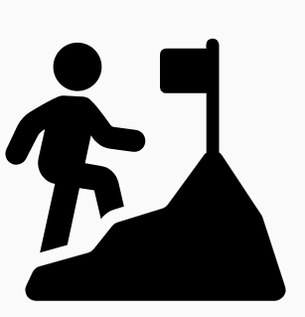 | 
Inspiring joy for learning | Knowledge rich | Reading at the heart | Challenge for all | Holistic approach

 | Autumn 1 | Autumn 2 | Spring 1 | Spring 2 | Summer 1 | Summer 2
Writing curriculum  Purpose  Text Types – what the children will write | Write to Entertain  Character descriptions  Poetry | Write to Inform  Diary Entry  Non-fiction writing: Recount (real events) of the Great fire of London  Fact file on Great Fire | Writing to Entertain  Writing Narrative  Descriptions of characters and settings | Write to Inform  Letters  (informal in role as the main character)  Instructions | Write to Entertain  Descriptions  Writing Narrative | Write to Inform  Diary Entries  Writing stories based on a model: Traditional Tales
Class text for writing lessons | Supertato – Paul Linnet and Sue Hendra  The Story Machine - Tom McLaughlin  Poetry – selected poems | Vlad and the Great Fire of London – Kate Cunningham  The Great Fire of London – Davidson Zanna | Snail and the whale – Julia Donaldson  Leon and the Place Between – Angela McAllister | Gregory Cool – Caroline Binch  How to catch a dragon – Adam Wallace | Journey – Aaron Becker  Classic Poetry – selected poems | Lilia and the Secret of Rain – David Conway and Jude Daly  Jim and the Beanstalk – Raymond Briggs
Text level features | Adjectives to convey a character’s appearance and personality  Third person narration  Past tense  Rhymes and repeated phrases | First person  Past tense  Thoughts, feelings and reflections (diary)  Sequencing events (recount)  Use questions to create headings (fact file) | Past tense  Rhyme  Third person narrative  Adjectives to describe a setting | First person  Sequencing events  Numbers to separate instructions  Imperative (bossy) verbs | Adjectives to create an atmosphere  Third person narration  Past tense | First person  Past tense  Sequencing events (narrative, traditional tales)  Writing stories based on a model (traditional tale)  Comparing two traditional tales  The power of three
Grammar and sentences | What is a sentence?  Oral rehearsal of sentences  Expanded noun phrases to describe and add detail  Coordination (and…, but…) – link sentences to give more information  Subordination (because) – link sentences to give reasons / explanations | Sentences with different forms: statements and questions  Verbs to indicate time: the past tense for events which have already happened  Adverbs to sequence events in chronological order  Subordination using because to give explanations | Sentences with different forms: statements, exclamations to express surprise  Co-ordination, linking sentences using: and, or, but  Subordination using: when (to indicate time)  because (to give reasons)  Expanded noun phrases: using adjectives to create atmosphere and give detail [Leon and the Place Between]  Use adverbs to describe how things happened [Leon and the Place Between] | Sentences with different forms: statements, questions, commands, exclamations  Co-ordination using: and or but  Subordination using: when, if, that, or, because  Consistent use of past tense (narrating events)  Consistent use of present tense (in letter, to describe routine actions and feelings/emotions) | Expanded noun phrases to create an atmosphere / for effect  Time words and story language to open sentences (avoid repetition of subject)  Consistent use of past tense (past progressive when narrating Journey)  Appropriate use of coordination and subordination  Subordination using: when to indicate time  Sentences with different forms (all four types) | Sentences with different forms: statements, questions, exclamations, commands  Adverbials of time  Consistent use of past tense – narration  Consistent use of present tense – comparing two stories  Co-ordination using: and, or, but  Subordination using: when, that, because
Words and spellings | Segmenting spoken words into phonemes  New ways of spelling phonemes | Common exception words | Common homophones- there, their, they’re  Possessive apostrophe | Words with contracted forms | Add suffixes to spell longer words (-ly, -ness, -ment,  -ful, -less)  Words with contracted forms  Common exception words | Common homophones and near homophones  Common exception words  Add suffix -ly to spell adverbs
Punctuation | Consistent sentence punctuation for simple sentences (capital letters, finger spaces, full stops) | Full stop  Question marks | Apostrophes for singular possession  Exclamation marks | Commas for lists  Apostrophes for contractions [don’t, I’m] | Consistent sentence punctuation in narrative | All punctuation should be evident within writing  Revise any areas of difficulty
Grammatical terminology | Noun  Noun phrase  Adjective,  Sentence  Conjunction | Question  Verb  Sentence types- statements, questions and commands | Exclamation mark  Singular and plural  Suffix (ly: quickly, slowly)  Adjective  Adverb  Apostrophe  Noun, noun phrase | Past tense  Present tense  Apostrophe  Contractions | Adjective  Revise as appropriate | All previous language taught - revise as appropriate

