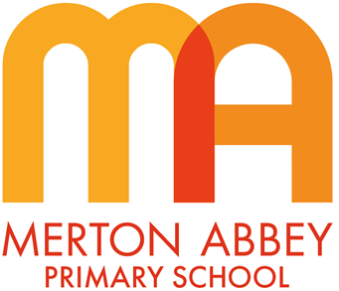
Curriculum Map 2023-2024
Our inclusive curriculum has been designed around the following aims:
 |  |  | 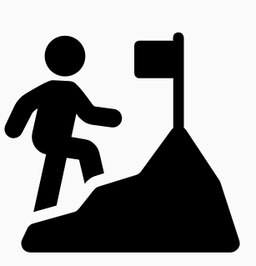 | 
Inspiring joy for learning | Knowledge rich | Reading at the heart | Challenge for all | Holistic approach

Year 4 | Autumn 1 | Autumn 2 | Spring 1 | Spring 2 | Summer 1 | Summer 2
Writing curriculum  Purpose  Text Types – what the children will write | Writing to entertain  Diary entry | Writing to inform  Newspaper  Poetry based on ‘The Iron Man’ | Writing to entertain  Narrative – from a particular character’s viewpoint  (Character descriptions) | Writing to persuade  Persuasive letters | Writing to inform  Science report | Narrative – mystery /adventure  (Setting descriptions)
Class text for writing lessons | Firework Makers Daughter – Phillip Pullman | The Iron Man – Ted Hughes | Edward Tulane – Kate DiCamillo | A Planet full of Plastic – Neal Layton | Science texts  Teeth | Varjak Paw – S. F. Said
Text level features | Emotive language  Alliteration  Planned repetition  Facts and statistics  Adjectives for positive description | Recounting events in a chronological sequence  Reflecting on events – expressing personal opinion | Composing and rehearsing sentences orally, building in rich vocabulary  Organising paragraphs around a theme | First person narration  Develop paragraphs around a theme  Detailed description to convey a character’s feelings | Plan writing by discussing and recording ideas in science  Composing and rehearsing sentences with scientific vocabulary  Use organisational devices for non-narrative writing | Third person narration(?)  Detailed description to evoke suspense  Use paragraphs to organize in time sequence
Grammar and sentences | Imperative verbs  Subordinate clauses  Fronted adverbials of place  Rhetorical questions  Noun phrases to add detail and description | Subordinating conjunctions  Fronted adverbials of time  Noun phrases with prepositions  Present perfect tense | Using fronted adverbials to indicate time and place  Choosing nouns and pronouns to achieve clarity and cohesion and to avoid repetition | Nouns and pronouns for clarity and cohesion  Expanded noun phrases to give precise detail (convey character’s personality)  Subordinate clauses to add detail and description  Present perfect vs simple past tense: I thought vs I have thought | Use conjunctions (when, before, after, so because) adverbs (then, next, soon, therefore) and prepositions (during, in) to express time and cause  Using the present perfect tense in reports | Expanded noun phrases to convey mystery / suspenseful details  Fronted adverbials of manner to give detail about character’s actions  Simple vs progressive verb forms: He crept vs He was creeping…
Words and spellings | No nonsense spelling [NNS] | NNS | NNS  Suffixes and Prefixes | NNS | NNS  Scientific and topic vocabulary | NNS
Punctuation | Question marks  Exclamation marks | Exclamations  Possessive apostrophe | Using commas after fronted adverbials  Using and punctuating direct speech | Apostrophes for possession incl. plural | Consistent use of sentence punctuation in science reports  Bullet points | Commas for fronted adverbials  Speech punctuation
Editing | proof-read for spelling and punctuation errors | assessing the effectiveness of their own and others’ writing and suggesting improvements | read aloud their own writing, to a group or the whole class, using appropriate intonation and controlling the tone and volume so that the meaning is clear. | assessing the effectiveness of their own and others’ writing and suggesting improvements | proof-read for spelling and punctuation errors  proposing changes to grammar and vocabulary to improve consistency, including the accurate use of pronouns in sentences | proof-read for spelling and punctuation errors
Grammatical  terminology | Imperative (bossy) verb  Expanded noun phrases | Subordinating conjunctions  Fronted adverbials of time | Determiner, adverb, adverbial | Past simple and present perfect tense | Pronoun, possessive pronoun, conjunction, adverb, preposition | Simple and progressive past Tense

