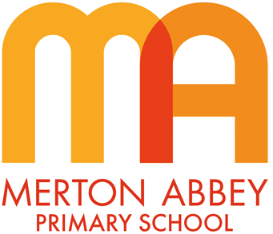
Computing Curriculum Map 2025-2026
Our inclusive computing curriculum has been designed around the following school curriculum aims:
 |  |  |  | 
Inspiring joy for learning | Knowledge rich | Reading at the heart | Challenge for all | Holistic approach

Our computing curriculum has been organised around the following 10 taxonomy strands which underpin all of our substantive and disciplinary knowledge:

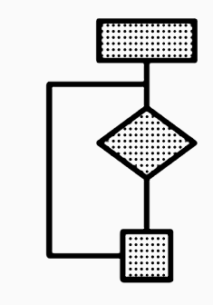 | Algorithms — Be able to comprehend, design, create and evaluate algorithms
 | Computer networks — Understand how networks can be used to retrieve and share information and how they come with associated risks
 | Computer systems — Understand what a computer is and how its constituent parts function together as a whole
 | Creating media — Select and create a range of media including text, images, sounds, and video
 | Data and information — Understand how data is stored, organised and used to represent real-world artefacts and scenarios
 | Design and development — Understand the activities involved in planning, creating, and evaluating computing artefacts
 | Effective use of tools — Use software tools to support computing work
 | Impact of technology — Understand how individuals, systems, and society as a whole interact with computer systems
 | Programming — Create software to allow computers to solve problems
 | Safety and security — Understand risks when using technology, and how to protect individuals and systems

Progression across key stages and year groups:
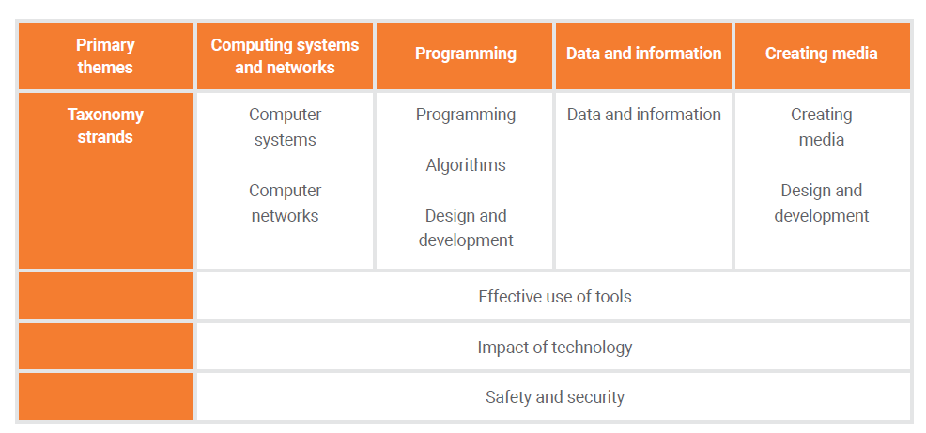

KS1 unit summaries and order
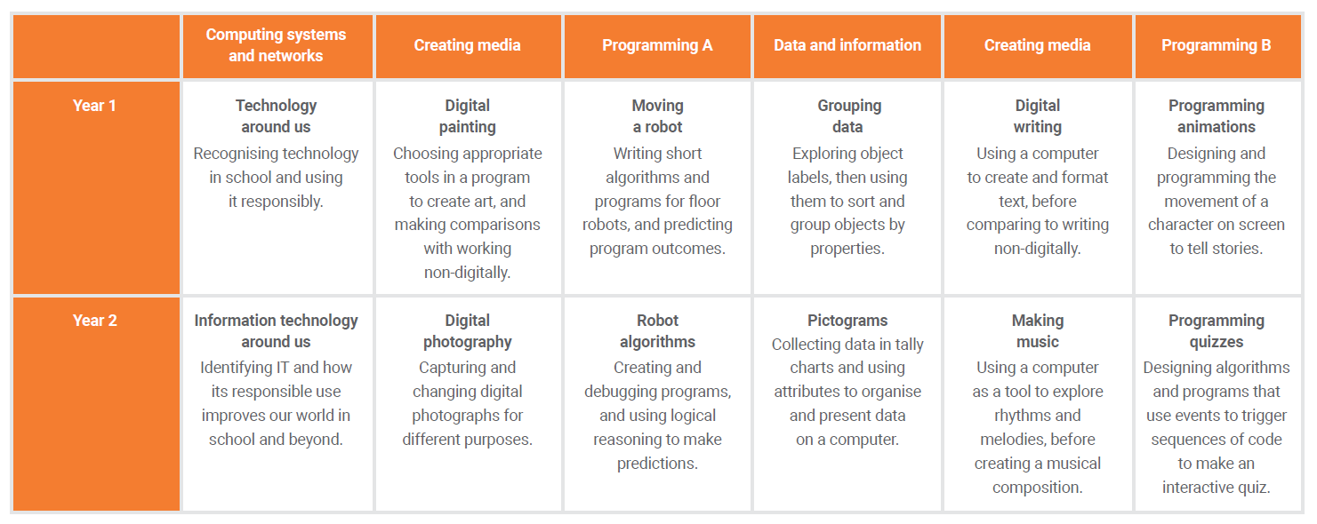

LKS2 unit summaries and order

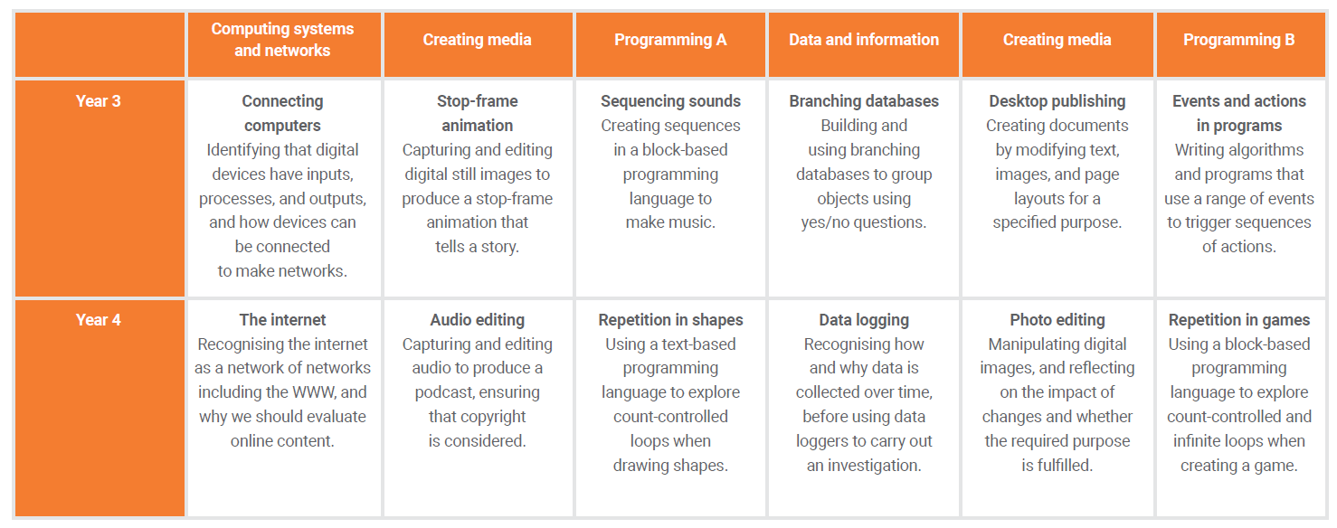

UKS2 unit summaries and order

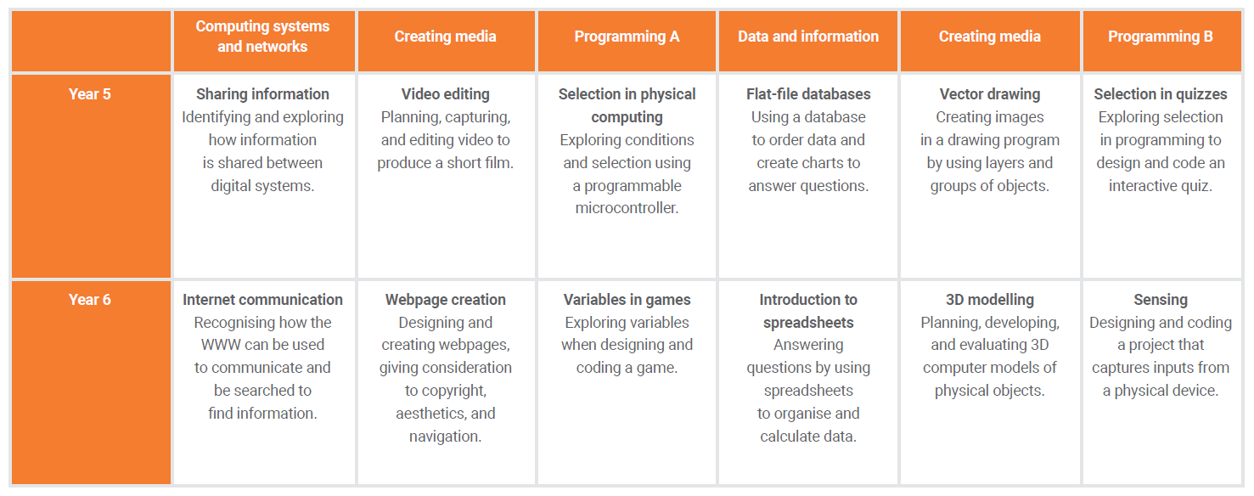

In 2021-2022, both KS1 classes will be teaching the Year 1 programming units. All KS2 classes, will be teaching the Y3 programming units as the children have not used the program before and there are key skills that are needed before the other units are taught.

