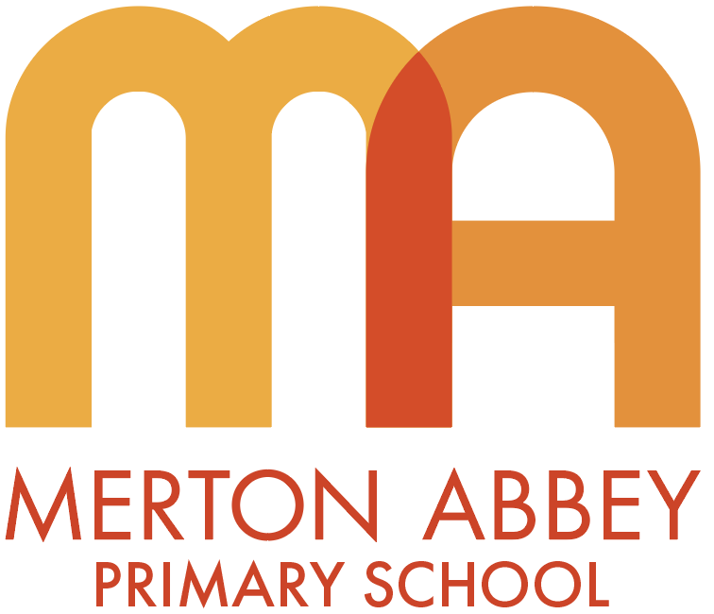

Art and Design policy

This policy will be reviewed in full on a two-year basis.
This policy was reviewed and updated in March 2025
Next review date: September 2026
Member of staff responsible for monitoring and reviewing the policy: Mark Oglesby

Intent

Rationale for art and design

“Every child is an artist” – Pablo Picasso

“Every artist was first an amateur” – Ralph Waldo Emerson

At Merton Abbey, our school’s motto is ‘Working hard, and caring for each other’, and this is reflected in teaching the Arts at our school; children achieving great success along their Art’s journey and reflecting and celebrating each other along the way. From Nursery to Year 6, children become balanced and reflective citizens ready for secondary school. Children are taught to have a Growth Mind-set, that, rather than saying they can’t do it, more of, they can’t do it yet.

Art, craft and design embody some of the highest forms of human creativity. A high-quality art and design education should engage, inspire and challenge pupils, equipping them with the knowledge and skills to experiment, invent and create their own works of art, craft and design. As pupils progress, they should be able to think critically and develop a more rigorous understanding of art and design. They should also know how art and design both reflect and shape our history, and contribute to the culture, creativity and wealth of our nation.

Aims (from the National Curriculum)
The national curriculum for Art & Design aims to ensure that all pupils:

- produce creative work, exploring their ideas and recording their experiences
- become proficient in drawing, painting, sculpture and other art, craft and design techniques
- evaluate and analyse creative works using the language of art, craft and design
- know about great artists, craft makers and designers, and understand the historical and cultural development of their art forms.

Curriculum design
Our art and design curriculum is focused on learning skills based on the 7 formal elements – colour, form, line, pattern, shape, texture and tone. Throughout the children’s school-life, they will develop these skills explicitly before being able to apply them to a specific design. They will make decisions for purpose, and learn key vocabulary around these elements.

Being aware of these fundamental principles in art and design, gives the children the knowledge and skills to understand and develop as they progress through the school. By analysing artists’ work, they will form a bridge between the key skills learnt and how they are represented in real-life pieces of art.

EYFS
Children at this age are naturally creative. By the end of Reception, children will have had many opportunities creating with materials, and to be imaginative and expressive. All art will be linked to the school’s half-term themes of Me and My Family, Celebrations, Food, Plants and Growth, Animals, and South Wimbledon. Across these six themes, children will experiment with colour mixing; create self-portraits; manipulate and work with natural and man-made materials and objects; create junk modelling; work with oil pastels, pencils and paints; and learn how to do observational drawings.
KS1
In Years 1 and 2, children are introduced to the formal elements - colour, form, line, pattern, shape, texture, and tone. The skills in these elements are taught explicitly before they have the opportunity to apply their understanding for specific purposes.
Children also develop skills such as printing, colour mixing, mixed media experimenting, sculpture, craft, shading and collage.
The artwork of artists such as Louis Wain, Julian Opie, and Clarice Cliff are analysed and its respecting skills learned and developed.
LKS2
In Years 3 and 4, children continue to learn about the formal elements of pattern, shape, texture and tone, and the development of these skills.
Children begin to look at prehistoric art and learn how art was produced thousands of years ago. Using similar resources at the time such as charcoal, children understand how the earliest pieces of art were created in caves.
Many more artists and their works are analysed. Carl Giles, Ann Roth and Diego Velázquez in Year 3, and work by David Hockney, Fiona Rae, Giuseppe Arcimboldo, Paul Cézanne, Sokari Douglas Camp, Edward Hopper and Paulo Rego, in Year 4.

UKS2
In Years 5 and 6, children are introduced to architecture, photography, and still-life. Year 5 children will look at advertising and designs for purpose. Artists such as John Singer Sargent, Magdalene Odundo, and Banksy will be analysed. In Year 6, artists such as Pablo Picasso, Käthe Kollwitz, Claude Monet, and Edvard Munch are studied.

Core concepts
- Drawing - ‘Can they use 2D shapes to draw?’ ‘Can they show control and techniques using a range of drawing materials?’ ‘Can they draw still-life from observation?’ ‘Can they draw perspective and negative space?’

- Painting - ‘Do they know the Primary colours and how Secondary colours are made?’ ‘Can they paint with creativity and expression?’ ‘Can they produce shade and varying tones of a colour?’

- Craft, Design, Materials and techniques - ‘Can they demonstrate skills and techniques using various materials such as clay, printmaking, and sculpture?’ ‘Can they reuse materials for a purpose?’ ‘Can they create art using photography and digital art?’

Core concept | Definition
Formal element: colour  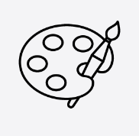  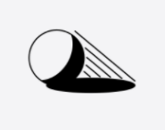 | Children know the primary colours and how to mix them to create secondary colours. Within these 6 colours, they can create shades and tints.  They can describe their colour selections and justify their reasons for different purposes. From this they can express feelings and emotions through colour.
Formal element:  form | Children will learn about form and how space is taken up by it. They will study by making sculptures.  Children will extend their practical ability to create 3D sculptural forms and begin to understand how to represent form using in a range of materials, including drawing.
Formal element:  line  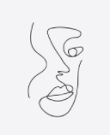 | Children will use, express and experiment with line for purpose, then use appropriate language to describe different lines.  They will draw lines with increased skill and confidence, and develop a greater understanding of applying expression when using line. Children learn and apply symmetry to draw accurate shapes.
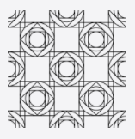  Formal element: pattern | Children understand and identify patterns in nature and from man-made materials. They will create original designs for patterns using geometric repeating shapes. They do this by learning a range of techniques to make repeating and non-repeating patterns.
  Formal element: shape | Children explore how shapes are used in artists’ work by identifying, drawing, and labelling shapes within images and objects. They will describe and use shape for purpose. Children compose geometric designs by adapting the work of other artists to suit their own ideas.
Formal element: texture  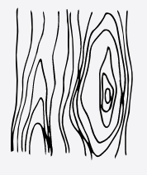 | Children will develop their understanding of texture through practical making activities. They will be able to give reasoning to how something feels. They will use, identify and describe materials to help create different textures.
Formal element: tone  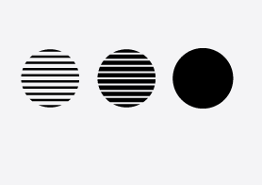 | Children will understand that varying degrees of lightness or darkness gives rise to what tone is and how to apply this to their own work. They do this by developing skill and control through experimenting. Use a variety of tones to create different effects and 3D effects.  Children will increase their awareness of using tone to describe light and shade, contrast, highlight and shadow.
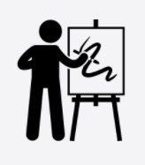  Analysis of artists | It is important that children analyse many artists’ work from Year 1 to Year 6. By referring to these 7 formal elements when looking at real life pieces of art, children will have a greater understanding of how these skills are used in real pieces of artwork. They will bridge the connection between what they have learnt to art in the real world.

Implementation (how we teach our curriculum)
Curriculum - The school’s curriculum is arranged that Years 1 to 6 will have three half-term units per academic year – Autumn, Spring and Summer. Units are linked to the school’s curriculum map as much as possible E.g. Year 2 children will learn Sculpture and mixed media, that focuses on superheroes, which links their learning to their focus book, Supertato.
Modelling – Children will see first-hand how skills and techniques are applied by observing the teacher using the visualiser. Also, children will watch videos presented by Art and Design specialists that are specific to the lesson’s objective.
Vocabulary – In every session, it is vital that children use the specific language that is associated with that lesson or unit. When teaching, children will hear key vocabulary used and what context it is in.
Inclusion – Art is for every child. Every child will be present and will be supported at their level. There will be a natural range of abilities so positive encouragement, appropriate resources and a whole-class support approach is paramount.
Analysis – Children will analyse many artists and their respective works. They will make connections between the discrete skills that have been taught to the real artwork they are examining. This further deepens their understanding of the formal element in a wide range of artwork.
Sketchbooks – These will have many uses. It is a resource where children will practise specific skills and techniques using a variety of materials. Children will stick in completed work to build up their personal portfolio of what they have learnt in the year. Evidence of the child’s progression will be observed over time. When taking part in discussions during book studies, children will use their sketchbooks to talk freely about work they are proud of and what they have learnt.
Design for purpose – A key aspect of creating art is by making choices. When making choices, children will have the opportunities to give reason as to why they have made those choices on colour etc.
Vocabulary – Will children be able to talk confidently about their work, using the correct vocabulary?
Evaluation – Looking at and discussing their own work gives children the opportunity to reflect, assess and improve their own art as well as others. Encouraging children to do this by using key vocabulary, further deepens their understanding of art. Teachers will model how to evaluate a piece of art to encourage children to do likewise.

Impact
Picture building – This will be carried out by the Subject Lead to assess the impact of the school’s planned curriculum. This will consist of:
- Pupil Book Study: Involves looking at children’s sketchbooks. Children will have the opportunity to share work they are proud by giving reasonings why. Teachers can ask children about what they have learned so the sketchbooks will act as prompts to support them.

- Learning observations/walks: To make sure the intended curriculum is taught, and to offer help, if needed, to any teacher.
Retrieval – At the start of each session, short reminders will help refresh and support children’s understanding of key vocabulary, especially if it is linked to the session.
Knowledge catcher – These are short picture-questions that can be used at the start or end of a unit. If used at the start, it gives the teacher an idea of how much the children know prior to what will be taught.
Analysis – Teachers will gauge how easily and effectively children talk when analysing artists’ work when they use vocabulary in line with the 7 formal elements. Will the children remember the definitions of each; will they need support in using it in context; and can the children give plausible reasons when comparing artists’ work to that of their own.
Evaluating – Children need to express positively and constructively on their own work. Children will write what needs to improve and what they like of their own artwork.
Quizzes – At the end of each unit, children can take part in a short multiple-choice quiz to show what they have learnt.

Appendix
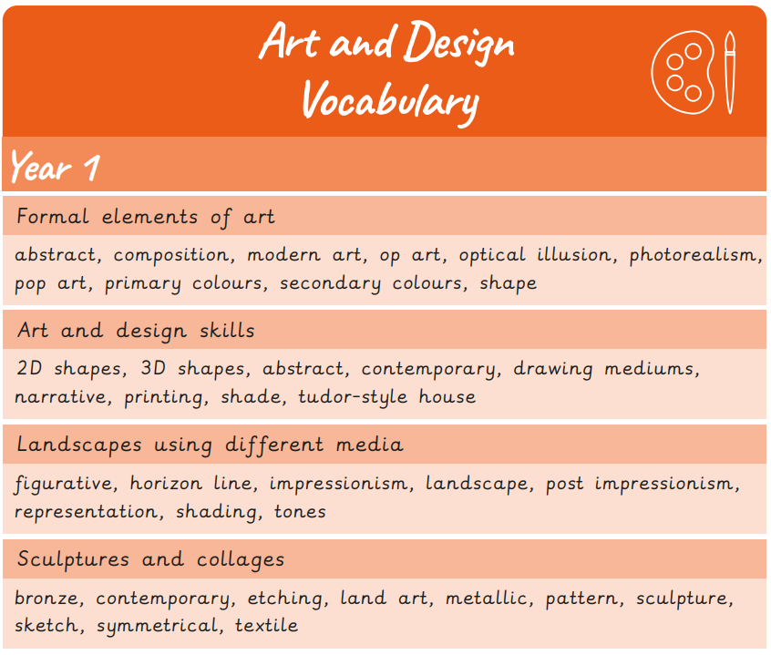
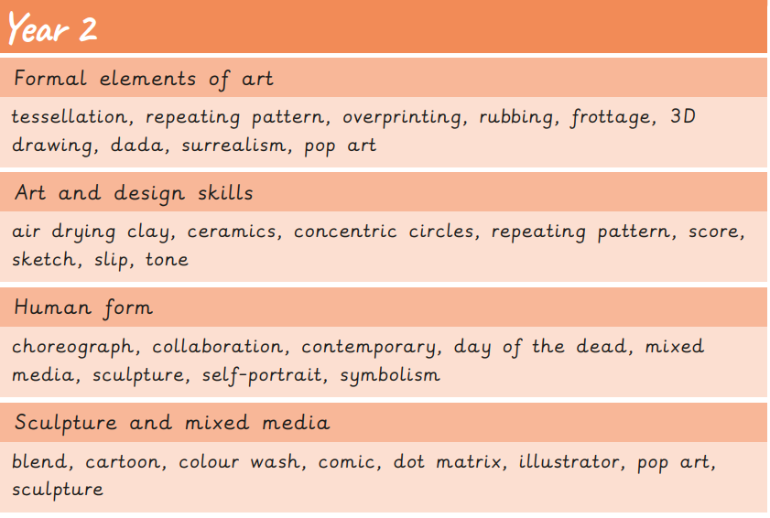
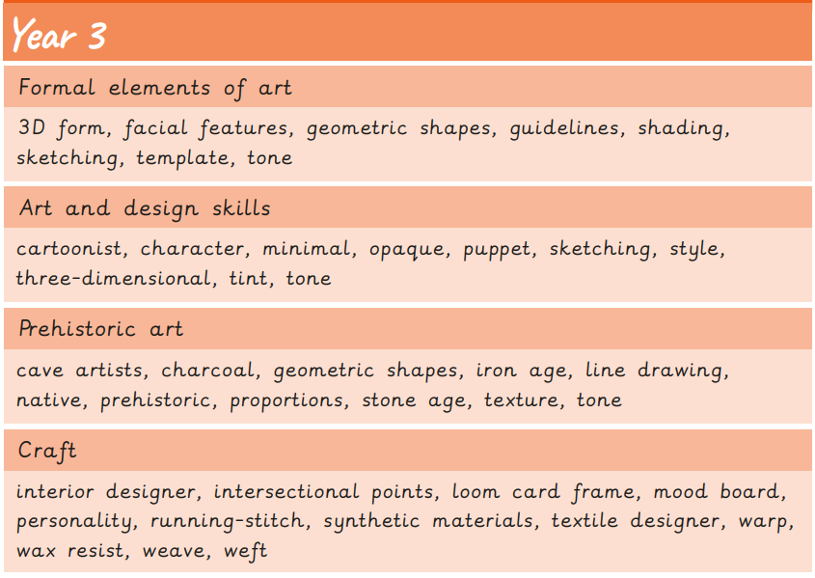
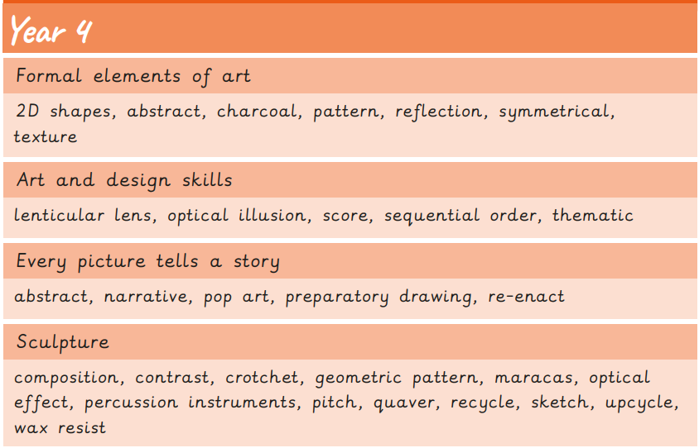

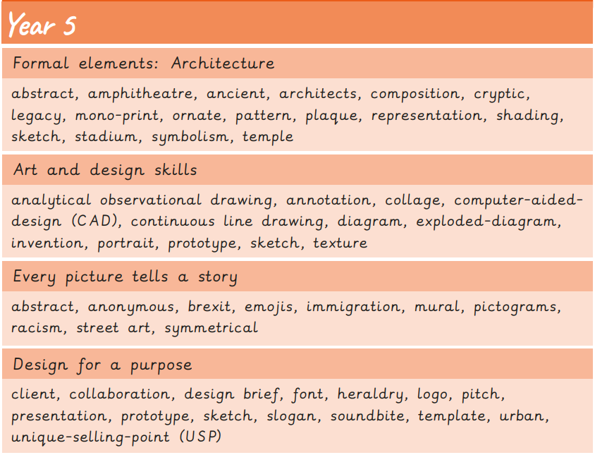

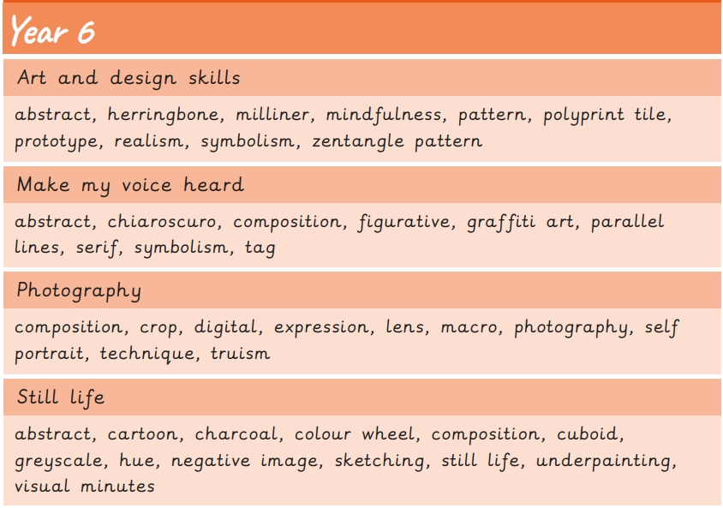

- Colour theory


