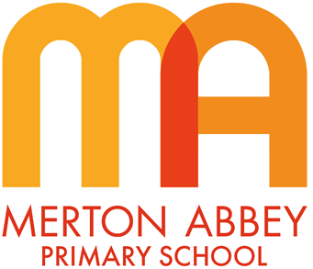
Art and Design Curriculum Map 2025-2026
Our inclusive art and design curriculum has been designed around
the following school curriculum aims:
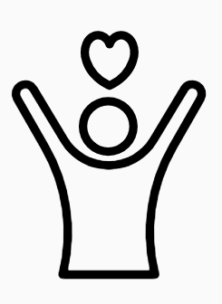 | 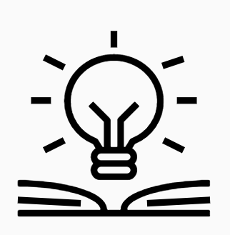 |  | 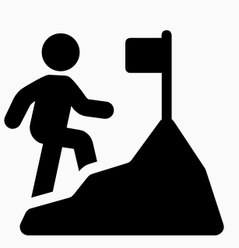 | 
Inspiring joy for learning | Knowledge rich | Reading at the heart | Challenge for all | Holistic approach

Our art and design curriculum has been organised around the following 3 skills which underpin all of our substantive knowledge:
- Drawing ‘Can they use 2D shapes to draw?’ ‘Can they show control and techniques using a range of drawing materials?’ ‘Can they draw still-life from observation?’ ‘Can they draw perspective and negative space?’
- Painting ‘Do they know the Primary colours and how Secondary colours are made?’ ‘Can they paint with creativity and expression?’ ‘Can they produce shade and varying tones of a colour?’
- Craft, Design, Materials and techniques ‘Can they demonstrate skills and techniques using various materials such as clay, printmaking, and sculpture?’ ‘Can they reuse materials for a purpose?’ ‘Can they create art using photography and digital art?’

During the course of our art and design curriculum, our children will also develop the following disciplinary knowledge:
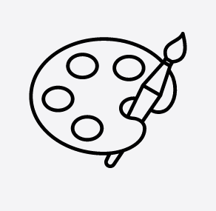 | 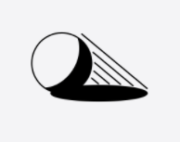 | 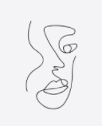 | 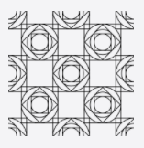 |  | 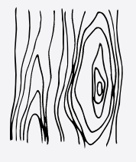 | 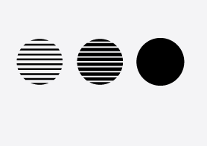 | 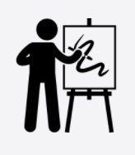
Formal element: colour | Formal element:  form | Formal element:  line | Formal element: pattern | Formal element: shape | Formal element: texture | Formal element: tone | Analysis of artists
How has the artist used colour to set the mood of the artwork? | How has the artist used shading to create a 3D effect? | How has the artist used static or dynamic lines? | What effect does the repeating motif have on the viewer? | What 2D and 3D geometric shapes can you see? | How is the mood of the art related to the materials used? | What effects do the varying tones have on the viewer? | What is the artist’s story behind their artwork?

 | Autumn 1 | Autumn 2 | Spring 1 | Spring 2 |  | Summer 1 | Summer 2
EYFS theme | Me and My Family | Celebrations | Food | Plants and Growth |  | Animals | South Wimbledon
Year 1
Unit of work | Formal elements |  | Skills |  |  | Landscapes using different media
Key concepts | Exploring;  Shape  Line  Colour |  | Printing  Mixing  Mixed-media |  |  | Composition Texture
Year 2
Unit of work | Sculpture and mixed-media: Superheroes |  |  | Formal elements |  | Skills
Key concepts | Sculpture  Pop Art  Facial features to portray emotions |  |  | Pattern  Texture  Tone |  | Craft  Design  Shading  Art appreciation
Year 3
Unit of work |  | Prehistoric art | Craft and skills |  | Formal elements
Key concepts |  | Charcoal  Paint | Tints  Shade  Mood board |  | Shape  Tone  Form
Year 4
Unit of work |  | Formal elements | Every picture tells a story |  |  |  |  | Skills
Key concepts |  | Texture  Pattern  Printing | Analyses of artists  Inference  Collage |  |  |  |  | Design  Craft  Painting  Art appreciation  Sculpture
Year 5
Unit of work |  | Design for a purpose | Formal elements |  | Every picture tells a story
Key concepts |  | Designing space  Advertising | Architecture  Observational drawing  Perspective |  | Analyses of artists  Artists’ meanings  Behind their art
Year 6
Unit of work | Make my voice heard |  | Still life |  |  |  |  | Photography
Key concepts | Drawing  Painting  Sculpture  Picasso - Guernica |  | Composition  Negative medium  Still life |  |  |  |  | Truisms  Self-portraits  Expressions  Composition  Colour

