Art & Design: Progression in Disciplinary knowledge
 | Year 1 | Year 2 | Year 3 | Year 4 | Year 5 | Year 6
Formal element: colour   | Remember the primary colours and how to mix them to create secondary colours.  Create shades of a colour and choose and justify colours for purpose. | Mix, apply and refine colour mixing for purpose using wet and dry media.  Describe their colour selections. | Increase awareness and understanding of mixing and applying colour, including use of natural pigments.  Use aspects of colour such as tints and shades, for different purposes. | Analyse and describe colour and painting techniques in artists work.  Manipulate colour for print. | Select and mix more complex colours to depict thoughts and feelings. | Mix and apply colours to represent still life objects from observation.  Express feelings and emotions through colour.  Study colours used by Impressionist painters.
Formal element:    form | Learn about form and space through making sculptures and developing language. | Extend their practical ability to create 3D sculptural forms and begin to understand how to represent form when drawing. | Further develop their ability to describe 3D form in a range of materials, including drawing. | Develop their ability to describe and model form in 3D using a range of materials.  Analyse and describe how artists use and apply form in their work. | Further extend their ability to describe and model form in 3D using a range of materials. | Express and articulate a personal message through sculpture.  Analyse and study artists’ use of form.
Formal element:  line  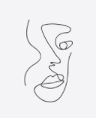 | Use, express and experiment with line for purpose, then use appropriate language to describe lines. | Draw lines with increased skill and confidence.  Use line for expression when drawing portraits | Express and describe organic and geometric forms through different types of line. | Learn and apply symmetry to draw accurate shapes.  Analyse and describe how artists use line in their work | Extend and develop a greater understanding of applying expression when using line. | Deepen knowledge and understanding of using line when drawing portraits.  Develop greater skill and control.  Study and apply the techniques of other artists.
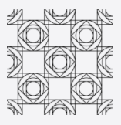  Formal element: pattern | Understand patterns in nature, design and make patterns in a range of materials. | Learn a range of techniques to make repeating and nonrepeating patterns.  Identify natural and man-made patterns. Create patterns of their own. | Construct a variety of patterns through craft methods.  Further develop knowledge and understanding of pattern. | Create original designs for patterns using geometric repeating shapes.  Analyse and describe how other artists use pattern. | Construct patterns through various methods to develop their understanding. | Represent feelings and emotions through patterns.  Create sophisticated artwork using their knowledge of pattern.
  Formal element: shape | Identify, describe and use shape for purpose. | Compose geometric designs by adapting the work of other artists to suit their own ideas. | Identify, draw and label shapes within images and objects.  Create and form shapes from 3D materials. | Create geometric compositions using mathematical shapes.  Analyse and describe the use of shape in artist’s work. | Composing original designs by adapting and synthesising the work of others.  Analyse and evaluate artists’ use of shape. | Fluently sketch key shapes of objects when drawing.  Create abstract compositions using knowledge of other artists’ work.
Formal element: texture  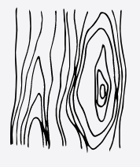 | Use materials to create textures. | Identify and describe different textures.  Select and use appropriate materials to create textures. | Analyse and describe texture within artists’ work. | Use a range of materials to express complex textures. | Develop understanding of texture through practical making activities. | Understand how artists manipulate materials to create texture.
Formal element: tone  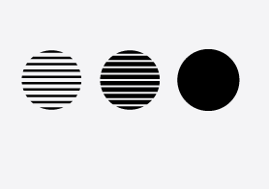 | Understand what tone is and how to apply this to their own work. | Experiment with pencils to create tone.  Use tone to create form when drawing. | Develop skill and control when using tone.  Learn and use simple shading rules. | Use a variety of tones to create different effects.  Understand tone in more depth to create 3D effects.  Analyse and describe use of tone in artists’ work. | Develop an increasing sophistication when using tone to describe objects when drawing.  Analyse artists’ use of tone. | Increase awareness of using tone to describe light and shade, contrast, highlight and shadow.  Manipulate tone for halo and chiaroscuro techniques.
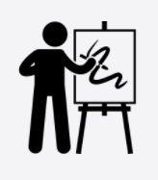  Analysis of artists | Study the work of the artists: Milhazes, Riley, Hockney, Celmins, Wain, Kandinsky, Bernal, Bolotowsky, van Gogh, Johns, Renoir, Sorolla, Kroyer, Bourgeois | Study the work of the artists: Ernst, Ruscha, Cliff, McCrosky, Hirst, Opie, Bridgeman | Study the work of the artists: Giles, Velazquez | Study the work of the artists: Ojeda, Cezanne, Morandi, Hockney, Rego, Hopper, Brueghel, Rae, Arcimboldo, Camp, Anatsui, Hepworth, | Study the work of the artists: Hundertwasser, Banksy, Warhol, Singer Sargent, Odundo, | Study the work of the artists: Monet, Morris, Hopper, Kollwitz, Picasso, Wallinger, Hoch, Kennard, Uelsmann, Holzer, Weston, Munch, Cezanne, Funke, Nicholson

