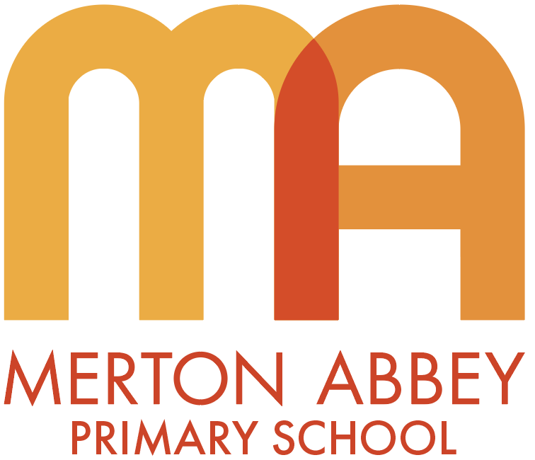

History policy

This policy will be reviewed in full on a two-year basis.
This policy was reviewed and updated in September 2023
Next review date: September 2025
This policy is reviewed by the Teaching and Learning committee.

Intent (what is meant to be learnt and what do we aspire for our children)
Rationale for history
“A people without the knowledge of their past history, origin and culture is like a tree without roots.” Marcus Garvey

“We are not makers of history. We are made by history.” Martin Luther King. Jr

In order to understand our current world, we must first understand our past. Through our high-quality, ambitious history curriculum, we encourage our children to be active learners who are inspired and shaped by the acts and thoughts of those before them. We want children to understand their place in the world, locally, nationally and globally by being immersed and influenced by history and develop a secure coherent knowledge about British, local and world history. Our curriculum inspires pupils’ curiosity to know more about the past. We challenge our children to ask perceptive questions, think critically, explore evidence, develop perspective, form arguments and make judgements. Through developing a strong knowledge of chronology, they can organise and understand the past and use this knowledge to inform their life choices, learning from the past, working together to make a better future.

Aims (from the National Curriculum)
Our curriculum for history aims to ensure that all pupils:
- know and understand the history of these islands as a coherent, chronological narrative, from the earliest times to the present day: how people’s lives have shaped this nation and how Britain has influenced and been influenced by the wider world
- know and understand significant aspects of the history of the wider world: the nature of ancient civilisations; the expansion and dissolution of empires; characteristic features of past non-European societies; achievements and follies of mankind
- gain and deploy a historically grounded understanding of abstract terms such as ‘empire’, ‘civilisation’, ‘parliament’ and ‘peasantry’
- understand historical concepts such as continuity and change, cause and consequence, similarity, difference and significance, and use them to make connections, draw contrasts, analyse trends, frame historically-valid questions and create their own structured accounts, including written narratives and analyses
- understand the methods of historical enquiry, including how evidence is used rigorously to make historical claims, and discern how and why contrasting arguments and interpretations of the past have been constructed
- gain historical perspective by placing their growing knowledge into different contexts, understanding the connections between local, regional, national and international history; between cultural, economic, military, political, religious and social history; and between short- and long-term timescales.

Curriculum design
Our history curriculum is knowledge and vocabulary rich allowing children to develop their understanding of abstract substantive and disciplinary concepts as they move through school. Our curriculum design ensures that children know more and remember more (sticky knowledge) and therefore form ever wider and deeper schemas.
Children will study a range of cultures and historical perspectives enabling them to be respectful, tolerant and empathetic. Children will leave Merton Abbey Primary being knowledgeable about key people, events and time periods from the past and will weave these together to form an overarching historical narrative.

EYFS
History is taught in the Early Years as an integral part of the topic work covered during the year. We have identified key stories and vocabulary which will help to develop children’s understanding of our key concepts. In the EYFS framework, history makes a significant contribution to the following ELGs:
Speaking: Children at the expected level of development will:
- Participate in small-group, class and one-to-one discussions, offering their own ideas, using recently introduced vocabulary.
- Offer explanations for why things might happen, making use of recently introduced vocabulary from stories, non-fiction, rhymes and poems where appropriate.
- Express their ideas and feelings about their experiences using full sentence, including use of past, present and future tenses and making use of conjunctions, with modelling and support from their teacher.
Past and present: Children at the expected level of development will:
- Talk about the lives of the people around them their roles in society.
- Know some similarities and differences between things in the past and now, drawing on their experiences and what has been read in class.
- Understand the past through settings, characters and events encountered in books read in class and storytelling.

KS1
During Key Stage 1, ‘pupils should develop an awareness of the past, using common words and phrases relating to the passing of time. They should know where the people and events they study fit within a chronological framework and identify similarities and differences between ways of life in different periods. They should use a wide vocabulary of everyday historical terms. They should ask and answer questions, choosing and using parts of stories and other sources to show that they know and understand key features of events. They should understand some of the ways in which we find out about the past and identify different ways in which it is represented.’ In our curriculum, year 1 children focus on continuity and change whilst historical significance is the focus of the work in year 2. Historical evidence and interpretation will be developed through each unit of work.

KS2
In Key Stage 2 pupils should continue to develop a chronologically secure knowledge and understanding of British, local and world history, establishing clear narratives within and across the periods they study. Children in LKS2 explore ancient and world history such as Ancient Greece, Ancient Egypt and Baghdad. British history is taught chronologically beginning with a study on the Stone Age to the Iron age in Year 5. Children then explore the Romanisation of Britain, the Anglo-Saxons and the Vikings. In year 6, children complete their history study by exploring the theme of crime and punishment over the course of British history. This unit gives the children the opportunity to recap on some aspects of the history curriculum but also to develop and understanding of other periods in history such as the Tudor and Victorian periods.
They should note connections, contrasts and trends over time and develop the appropriate use of historical terms. They should regularly address and sometimes devise historically valid questions about change, cause, similarity and difference, and significance. They should construct informed responses that involve thoughtful selection and organisation of relevant historical information. They should understand how our knowledge of the past is constructed from a range of sources.

Core concepts
A core aim of our ambitious history curriculum is not simply knowing the facts; it is having a storehouse of knowledge that is powerful and later contributes to helping young people become skilful historians.

Concepts provide the schema through which meaning is made and connections are formed. They reach back into the past: where have we met this idea before? And they stretch into the future: how can we use this new information? Concepts help us to develop the intellectual architecture for meaning and for strengthening memory over time. Concepts have a powerful effect on learning and we believe that identifying the big ideas helps pupils to make sense of what they are taught. Concepts need to be the driver for the learning.
At Merton Abbey, we have 3 key substantive concepts for history that we aim to develop through the school. These vertical core concepts provide both a concrete lens through which to study and contextualise history, as well as a gradual, deep understanding of complex, abstract ideas:

- ‘Quest for knowledge’ How do people understand the world around them? What is believed; what is known; and what scientific and technological advances are made at the time? Why do people seek to rationalise?
- ‘Power, empire and democracy’ Who holds power, and what does this mean for individuals at different levels of society? How is this power legitimised? How are people’s rights different in different political contexts?
- ‘Community and family’ What is life like for people in different societies? How are these societies structured? How are family or community relationships different at different times and in different places?

We also aim to give our children a grounding in core disciplinary knowledge, and the ability to approach challenging, historically-valid enquiry questions. The following disciplinary knowledge concepts (this is how historians debate history) are also the drivers for our units. Each unit of work will focus on one concept and this will be reflected in the big question for the unit e.g. What did the early Islamic civilisation do for us? (historical significance).

Core concept | Definition
Time, change and chronology  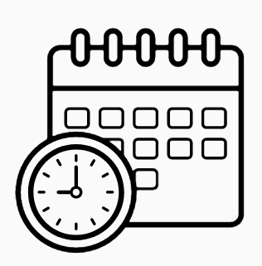 | To create a sense of period and time, the sequence of when things happened, what changed and what continued, what we might see as progress.  Each history unit at Merton Abbey begins with an understanding of the chronology of the unit: where this sits in a timeline in relation to what they have learnt already and also to their own lives.  There is a focus on the language and terminology of time (e.g. before, after, AD, BC etc), the sequencing of events and the sense of duration of a period.
Reasons and results  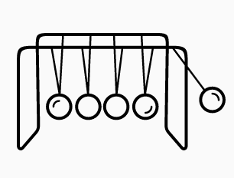 | How can explain why things happened in history, how did people make a difference to what happened? What followed as a result of these actions?  This concept is important as it helps children to make links between the cause and effect of actions in their life to a wider ranging context.  Children will discover how the decisions of a few people affected so many people over a period of time.
Significance   | The focus around this concept is on recognising why a person or event is of importance. Children are encouraged to evaluate the relevance of the contribution of different individuals or how an event came to affect future generations. Children can apply a number of criteria to evaluate significance such as the 5Rs. Was the person, place or event: remarkable (remarked upon by people at the time or since); remembered (Important at some stage in history); resulted in change (it/they had consequences for the future); resonant (people like to make analogies with it/them and it is possible to connect with consequences, beliefs or situations across time and space) and revealing (of some aspect of the past).  It is vital that children identify what makes a person or event significant rather than just narrating an individual’s life or reconstructing the event. It is also important to make the distinction between fame and significance. The focus is on effect rather than celebrity.
Historical evidence   | What do we use to find out about the past? How can we use this material safely to produce the best history we can? What are the problems when using historical sources?  To allow our children to aspire to be real historians and to think like real historians, we need to provide them with the opportunities to use methods and techniques used by real historians.  Our children will use a range of evidence to draw conclusions about events and developments in history. They will have the opportunity to think critically about different sources and to analyse the effectiveness and reliability of these sources. This core disciplinary concept is developed through every unit of work across the school.
Interpretations  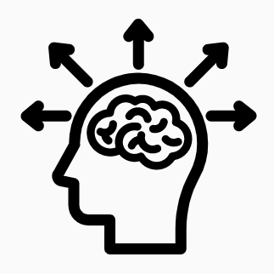 | How and why does the way that history is produced differ? Do we all understand the past in exactly the same way? How do we show what the past was like?
For further information on Source Analysis and questions to ask an artefact see Appendix 3 and 4.

In addition, we have a progression of disciplinary knowledge document which clearly set out how these concepts are developed across the school from EYFS to UKS2. This can be found on our school website.

Implementation (how we teach our curriculum)
- Each unit of work has a unit plan which identifies the key sticky knowledge (organised by substantive knowledge concepts); opportunities to develop disciplinary knowledge; subject knowledge for teachers; links to resources and videos; key vocabulary and then big questions for each lesson.

- Reviewing previous learning: Lessons will begin with a retrieval practice activity to ensure to ensure that children ‘know more and remember more’. The key sticky knowledge for each unit of work is identified on unit plans and teachers use this information to help children recall learning from earlier in the year and from earlier year groups.

- Focus on vocabulary: Lessons will focus on key vocabulary which will be taught explicitly and children will be expected to use the new vocabulary throughout the lesson.

- Big questions: Each lesson will be centred around a big question which will be the focus for the learning. Big questions help to focus lessons on learning and children will be expected to be able to answer the question at the end of the lesson.

- Historical sources: Historical sources will be used to enhance historical understanding and to help children develop their disciplinary knowledge. Children will be encouraged to read and compare sources, explore why they were written and identify any potential bias. Sources are part of what make history unique. (see appendix 3 for more information on this)

- Independent work: Children will engage in generative independent work which will encourage children to think hard by connecting, explaining and applying their learning. This could involve writing, paired discussion or comparing and contrasting. This helps children to learn new content.

- Inclusion: All children (including those with SEND) will be included within the lesson through careful scaffolding of work, pre-teaching, teaching using small steps, dual coding, highlighting prior knowledge and the effective use of teaching assistants.

- Oracy: Children will be given the opportunity to discuss rich questions using cold calling and Think, pair share. Children will be expected to speak in complete sentences and use correct vocabulary. These rich discussions will help new learning move into the children’s working memory and help them to understand the new learning at a deeper level.

- Checking for understanding: Teachers regularly check for understanding during lessons to ensure that children understand the new learning and to intervene promptly if children are having difficulty. This could take the form of multiple-choice questions, discussion or summarising.

- Reading: Children will be given regular opportunities to read primary and secondary sources and non- fiction texts. They will be encouraged and supported to read as historians.

Impact
- When reviewing the impact of our curriculum we ask ourselves the following two questions:
- Have our pupils learned what they have been taught (what we intended them to learn)?
- How do we know?

In history teachers assess children’s learning in two ways:
- Teachers regularly assess/check for understanding throughout lessons which inform their decisions about next steps in learning. Formative assessment.
- End of unit assessments are used to identify which children are keeping up with the curriculum and to address in gaps in the children’s learning. Summative assessment.

- Regular picture building will be carried out by the subject leader to assess the impact of our planned curriculum. This will consist of:
- Pupil Book Study: This involves looking at pupils’ work and structured discussions with children about their learning to ensure the intended curriculum and to ensure that children know more, remember more and are able to do more. These discussions also explore attitudes towards history and give the children the opportunity to share what their teachers do that help them with their development in history.
- Learning observations/learning walks: These are used to ensure that the intended curriculum is being implemented effectively and to help teachers to identify areas for development.
- Assessment data: The % of children who are keeping up the curriculum is identified following end of unit assessments/rubrics.

All of this information helps to triangulate our judgements about the impact of our computing curriculum.

Appendix 1: Time line of key events in British and World history
Approximate date | British History |  | World History
130,000  BC | Neanderthal Britain
25000  BC | Ice Age
 |  | 5400 BC | World’s first city is established by the  Ancient Sumer
 |  | 5000 BC | Evidence of life in the Indus Valley
 |  | 3500 BC | Era of the Ancient Egyptians begins
3000 BC | New Stone Age – farmers arrive from  Europe
2800 BC | Stonehenge begins to be built
2100 BC | Bronze Age Era | 2000 BC | Maya Civilization begins
 |  | 1766 BC | Ancient Shang Dynasty begins
 |  | 1600 BC | Ancient Greek Era begins
 |  | 1136-  1327 | The age of the pharaohs – including  Tutankhamen
 |  | 1046 BC | Shang Dynasty ends
 |  | 850 BC | Sparta is formed
800 BC | Iron Age begins
 |  | 776 BC | First Olympic games
 |  | 753 BC | Romulus and Remus found Rome
 |  | 530 BC | Indus Valley invaded by Persia
500 BC | Celts arrive from Central Europe
 |  | 461-429 | Pericles- the Golden Age of Athens
 |  | 332 BC | Egypt invaded by Alexander the Great
 |  | 146 BC | Rome conquers Greece
 |  | 69 BC | Cleopatra Born
54 BC | Julius Caesar’s invasion attempt
 |  | 44 BC | Assassination of Caesar
 |  | 30 BC | Cleopatra dies. Egypt becomes a Roman Province
 |  | c.33 AD | Jesus crucified
43AD | Romans invade Britain (Claudius)
50 AD | London founded (Londinium)
61 AD | Boudicca leads the Iceni in a revolt  against the Romans
350 AD | Picts and Scots attack the border
410  AD | Roman withdrawal from Britain –  Anglo Saxons begin to settle | 410 AD | End of the Roman Empire
450 AD | First Anglo-Saxon Invasion
597 AD | St Augustine brings Christianity
602 AD | Canterbury Cathedral founded
731 AD | Bede’s church history completed
790 AD | First recorded Viking attack (Dorset)
793 AD | Viking attack on Lindisfarne
 |  | 768 AD | Baghdad ‘the round city’ is finished
 |  | 800 AD | Baghdad is largest city in the world
 |  | 900 AD | Benin begins
1066 AD | Norman Conquest- Battle of Hastings
1086 AD | Domesday book completed
1154 AD | Norman Era ends. Henry II becomes King
1215 AD | King John signs Magna Carta
 |  | 1400s | Benin is a wealthy kingdom
 |  | 1441 AD | Mayan’s revolt against a leader
1476 AD | William Caxton invents the first  printing press
1492-  1504 AD | Christopher Columbus completes four round trips between Spain and  the Americas
1509 AD | Henry VIII crowned King
 |  | 1541AD | Many Maya city states are conquered  by the Spanish
1558-  1603 AD | Queen Elizabeth is on the throne
1605 AD | Guy Fawkes’ gunpowder plot foiled
1633 AD | Samuel Pepys is born
1666 AD | Great Fire of London
1805 AD | Nelson wins Battle of Trafalgar
1837 AD | Queen Victoria ascends to the  Throne
1840 AD | Palm house in Kew gardens is built
1862 AD | Westminster Bridge is completed
1870 AD | Houses of Parliament are built –  architect – Charles Barry – now a UNESCO world heritage site
1871 AD | Royal Albert Hall is opened by  Queen Victoria
1880 AD | Elementary education for every child up to the age of 10 is made compulsory
1896 AD | William Morris – famous designer  dies
 |  | 1897 AD | Benin ends
1901 AD | Queen Victoria dies
1913 AD | Emily Davison, a famous suffragette  dies
 |  | 1922 AD | Howard Carter discovers the tomb of Tutankhamun
1928 AD | Women get the same voting rights  as men
1939 -1945 AD | WW2
 |  | 1955 AD | Rosa Parks refuses to give up her seat  on the bus
 |  | 1964 AD | Civil rights act is passed in USA –  discrimination is outlawed
 |  | 1969 AD | Neil Armstrong lands on the moon and is the first man to complete a moon  walk
1991 AD | Tim Berners- Lee designs first  website

Appendix 2: Key KS1 and KS2 historical terms

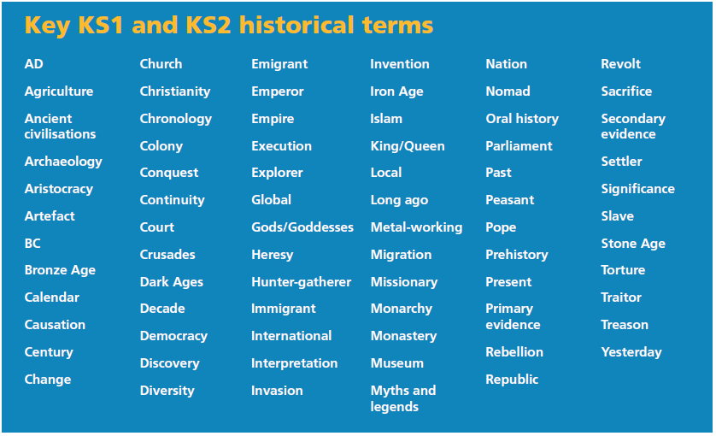

Key terminology and definitions:
BC: Before Christ; the number of years before Jesus was born. 33BC would mean 33 years before Christ was born.
AD: Anno Domini; Latin for Year of our Lord. AD 45 would be 45 years after the birth of Christ.
Chronology: Arranging dates or events in the order that they happened.

Appendix 3: Teaching Source Analysis
Teaching children how to analyse sources appropriately at primary school level is really important. This is because it gives them the opportunity to develop an understanding of questioning sources, a skill that they can transfer through subjects and life whilst also supporting them in being ready for the transition to KS3 History.
It also links particularly well with PSHE and teaching children about ‘fake’ news and recognising this.

Primary vs Secondary Sources
Sources: In looking at historical evidence, we look at sources. There are different types of sources.
- Primary sources: Primary sources are from the time of the event in question. They are direct evidence from eye witnesses who were there at the time of the event. A primary source can be in many forms, such as a letter, report, diary, memoir or artefact (e.g. art work, tools, clothing). Primary sources can be very useful in understanding how people felt at the time of an event.
- Secondary sources: A secondary source is one that is not from the time of the event in question. These sources may be complied after the writer has studied primary sources, and completed with the benefit of hindsight. However, they may be written after the writer has just studied other secondary sources. They can be a textbook, painting or any written evidence done after the event. Secondary sources can be very useful and may be well balanced, but it does depend where they got their information. When looking at historical evidence, it is important to consider the provenance of the source.

Bias/propaganda:
An important thing children need to be able to recognise when looking at sources is to consider whether there is any bias or propaganda attached to it. This will begin with needing to teach them what bias and propaganda are to develop their understanding of this, modelling examples and showing how they can question these sources. Ultimately, children need to know that not all historical sources can be trusted as they may hold a particular view or favour a particular side of the argument. For example, there is a famous diary entry that talks about King Alfred charging into a battle like a wild boar. Whilst he may well have done, this was written by someone from his side so children need to be able to question why he would be presented in such a way.

Provenance: The provenance of a source tells us who wrote a source, when they wrote it and for what purpose. We have to look at the provenance of a source to get a better understanding of how useful and reliable it is. A source written by an eyewitness may be biased, depending on what their personal objectives and opinions were at the time.
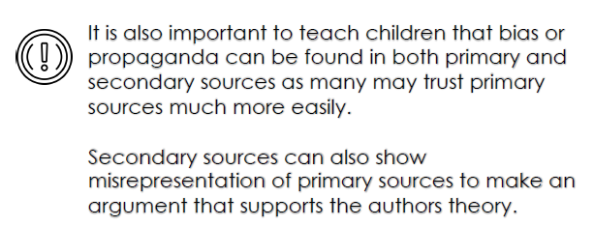
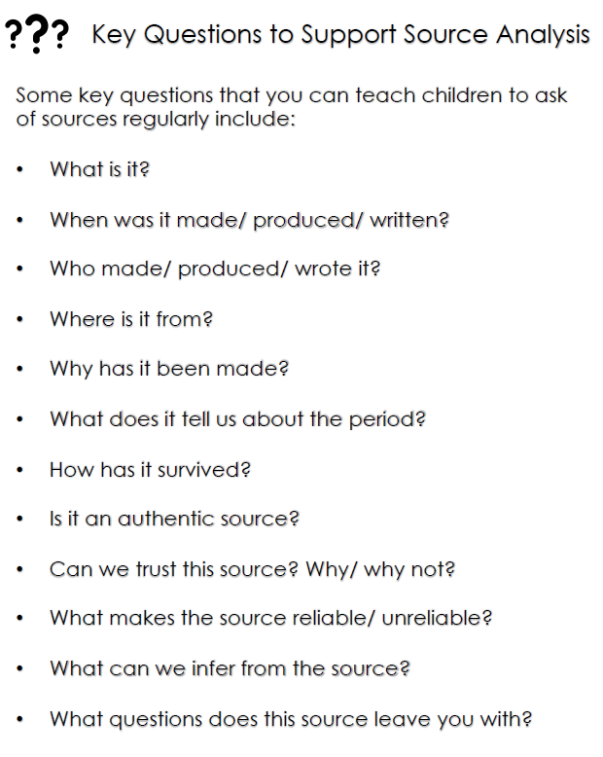
Appendix 4: Questions to ask an artefact
Artefacts are Primary sources.

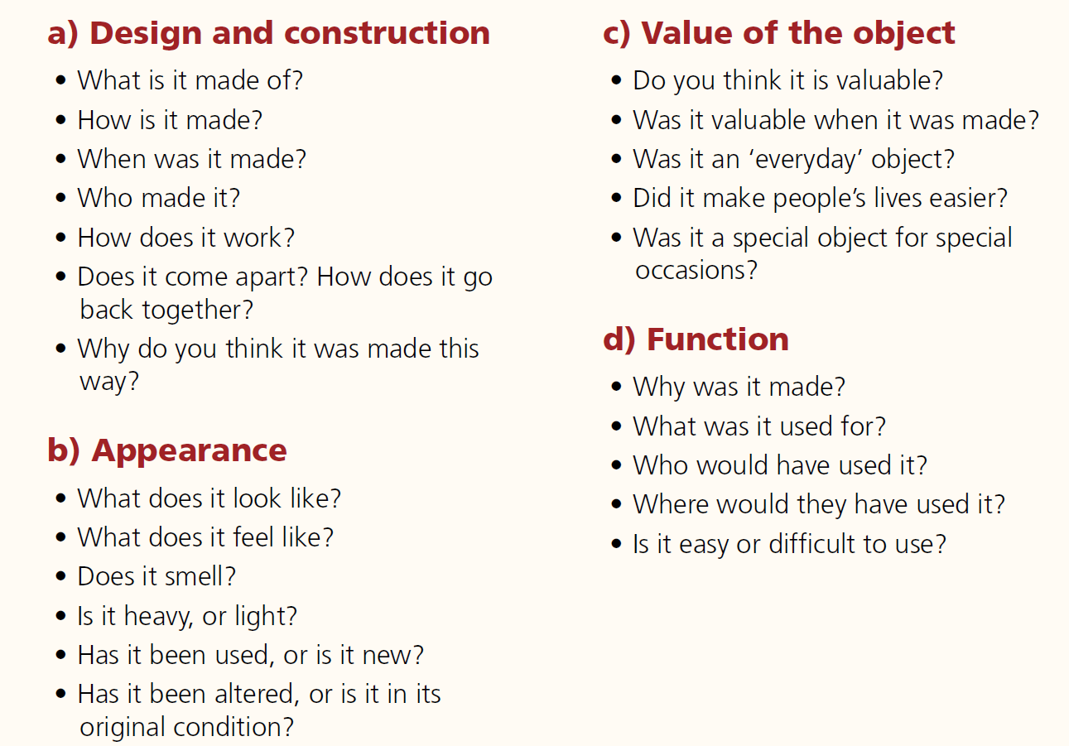

Appendix 5: Key questions for KS1 and KS2 units of work
KS1
People
Questions to ask about historical figures who are studied in years 1 and 2:

Characteristics:
What are the most important facts about this person?
What do these important facts tell me about this person? (focus on understanding, rather than knowing facts)

Where (linked to KS2 Elsewhere):
Where did this person come from?


Evidence:
How do we know about this person?

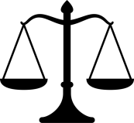
Significance:
What did this person achieve or help to achieve?
Did this person’s actions change anything for the future? How did they make a difference?

Timeline:
When in history did this person live? (birth dates and death dates)
Did this person live before or after [another person/event they have studied] lived/happened?
How many years before or after [another person/event they have studied] lived/happened did this person live?
What period of time did this person live in?
Did this person live within or beyond living memory? (living memory: can be remembered by people who are still alive now, not children’s own living memory)

Events
Questions to ask about historical events which are studied in years 1 and 2:
Characteristics:
What are the most important parts of (key facts about) this event?
What do these key facts tell me about this event? (focus on understanding, rather than knowing facts)
Where (linked to KS2 Elsewhere):
Where did this event take place?

Evidence:
How do we know that this event happened?

Significance:
Did this event change anything for the future? How did it make a difference?

Timeline:
When in history did this event happen? (day/month/year(s))
What period of time did this event happen in?
Did this event happen before or after [another person/event they have studied] lived/happened?
How many years before or after [another person/event they have studied] lived/happened did this event happen?
Did this event occur within or beyond living memory? (living memory: can be remembered by people who are still alive now, not children’s own living memory)

Periods of Time
Questions to ask about historical periods of time which are studied in years 1 and 2:
Characteristics:
What is similar about the way people lived in this time period and [another time period they have studied]?
What is different about the way people lived in this time period and [another time period they have studied]?
What are the most important things (key facts) to know about this period of time?
What do these key facts tell me about life in this period of time? (focus on understanding, rather than knowing facts)
What important events happened in this time?
Which important people lived in this time?
Where (linked to KS2 Elsewhere):
Did the things that happened in this time period happen in a particular place?
Were things the same everywhere in the world during this time period?

Evidence:
How do we know about this period of time?

Significance:
How did life change during this period of time?
Did this time period change anything for the future? How did it make a difference?

Timeline:
When did this period of time begin and end? (specific years and approximate number of years duration)
Was this period of time before or after [another person/event /time period they have studied] lived/happened?
How many years before or after [another person/event/time period they have studied] lived/happened was this period of time?
Did this period of time occur within or beyond living memory? (living memory: can be remembered by people who are still alive now, not children’s own living memory)

KS2
Whenever a new historical period or event is studied, ask these questions over the course of a unit:
Characteristics:
What were people’s lives like during this historical period?
What was/were society/culture/economy/military/religion/politics like during this historical period?
What else do I want/need to know about this historical period?

Historical Links:
How has this historical period influenced other historical periods?
How have other historical periods influenced this historical period?
How does this period/event compare to other historical periods/events (that have already been studied)?
Evidence:
What is the evidence for this historical event?

Significance:
What is significant about this historical event or period?
What were the main achievements of this historical period?
What were the follies of mankind in this historical period?
Timeline:
When did this event occur?
How long did this period last?
What came before and after this historical period?
Elsewhere:
What was going on elsewhere in the world during this historical period?


Response:
What do I think about this historical event?
What do others (past and present) think about this historical event?

