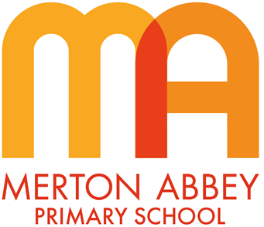
History Curriculum Map 2025-2026
Our inclusive history curriculum has been designed around the following school curriculum aims:
 |  |  | 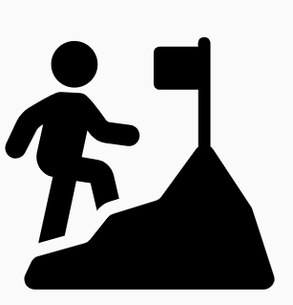 | 
Inspiring joy for learning | Knowledge rich | Reading at the heart | Challenge for all | Holistic approach

Our history curriculum has been organised around the following 3 key concepts which underpin all of our substantive knowledge:
- ‘Quest for knowledge’ How do people understand the world around them? What is believed; what is known; and what scientific and technological advances are made at the time? Why do people seek to rationalise?
- ‘Power, empire and democracy’ Who holds power, and what does this mean for individuals at different levels of society? How is this power legitimised? How are people’s rights different in different political contexts?
- ‘Community and family’ What is life like for people in different societies? How are these societies structured? How are family or community relationships different at different times and in different places?

During the course of our history curriculum, our children will also develop the following disciplinary knowledge:
 | 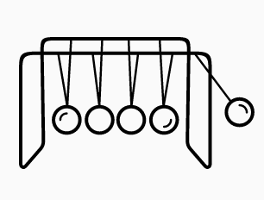 |  |  | 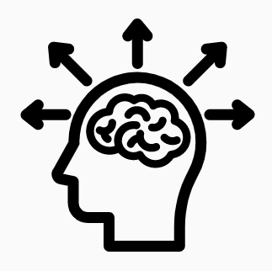
Time, change and chronology | Reasons and results | Significance | Historical evidence | Interpretations

 | Autumn 1 | Autumn 2 | Spring 1 | Spring 2 |  | Summer 1 | Summer 2
EYFS theme | Me and my family | Celebrations | Food | Plants and growth |  | Animals | South Wimbledon (people who help us)
Year 1
Unit of work |  | How have toys changed over time? |  | How has transport changed over time? |  | Why is Merton Abbey Mills so important?
Key concepts |  | Time, change and chronology  Historical evidence |  | Time, change and chronology  Historical evidence |  | Significance  Historical evidence
Year 2
Unit of work |  | How did the Great Fire change London? | What is special about Walter Tull? |  |  | Who was the greatest Queen: Queen Elizabeth I or Queen Victoria?
Key concepts |  | Reasons and results  Significance  Historical evidence | Significance  Historical evidence |  |  | Significance  Historical evidence
Year 3
Unit of work |  | How did the Ancient Greeks change the way we think today? | What did the Ancient Egyptians believe? |  |  |  |  | How were the Ancient Maya similar to the Greeks and Egyptians?
Key concepts |  | Reasons and results  Significance  Historical evidence | Time, change and chronology  Reasons and results  Historical evidence |  |  |  |  | Time, change and chronology  Interpretations  Historical evidence
Year 4
Unit of work |  | How did the Roman Empire change over time? |  | What made Cleopatra so special? |  |  |  | Why was Baghdad so significant in 900AD?
Key concepts |  | Time, change and continuity  Historical evidence |  | Interpretations  Significance  Historical evidence |  |  |  | Significance  Historical evidence
Year 5
Unit of work | How did Britain change from the Stone age to the Iron age? |  | How did the Romans change life in Britain? |  |  |  |  | How did the Windrush migration change Merton for the better?
Key concepts | Time, change and continuity  Historical evidence |  | Time, change and continuity  Interpretations  Historical evidence |  |  |  |  | Significance  Reasons and results  Historical evidence
Year 6
Unit of work | What can we learn about the Anglo-Saxons from what we see today? |  | Did the Vikings deserve their reputation? |  | How has crime and punishment changed since the Anglo-Saxon period?
Key concepts | Interpretations  Reasons and results  Historical evidence |  | Interpretations  Historical evidence |  | Time, change and continuity  Historical evidence

