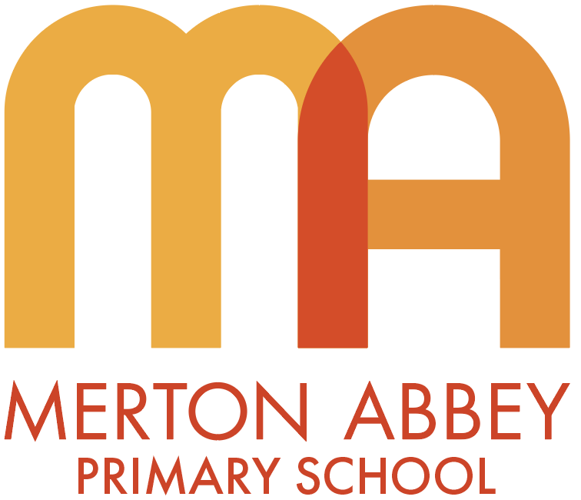

Design & Technology policy

This policy will be reviewed in full on a two-year basis.
This policy was reviewed and updated in September 2025
Next review date: September 2027
Member of staff responsible for monitoring and reviewing the policy: Clare Whitehead

Intent

Rationale for art and design

“Thinking about design is hard, but not thinking
about it can be disastrous.” - Ralph Caplan

“There are three responses to a piece of design – yes, no, and WOW!
Wow is the one to aim for.” — Milton Glaser

At Merton Abbey,
Our school’s motto is ‘Working hard, and caring for each other’, and this is reflected in the teaching of the Arts at our school: children achieving great success along their Arts journey and reflecting on and celebrating each other along the way. From Nursery to Year 6, children are taught to have a Growth Mindset, which means that, rather than saying they can’t do it, they can’t do it yet. Art, craft and design embody some of the highest forms of human creativity. A high-quality art and design education should engage, inspire and challenge pupils, equipping them with the knowledge and skills to experiment, invent and create their own works of art, craft and design. Children should be encouraged to develop the confidence to take risks, through drafting design concepts, modelling and testing, and to be reflective learners who evaluate their work and the work of others. As pupils progress, they should be able to think critically and develop a more rigorous understanding of art and design. They should also know that art and design both reflect and shape our history and contribute to the culture, creativity, and wealth of our nation. We aim to raise awareness of the impact of design and technology on our lives and encourage pupils to become resourceful, enterprising citizens with the skills to contribute to future design advancements.

Aims (from the National Curriculum)
The national curriculum for Design & Technology aims to ensure that all pupils:

- develop the creative, technical and practical expertise needed to perform everyday tasks confidently and to participate successfully in an increasingly technological world

- build and apply a repertoire of knowledge, understanding and skills to design and make high-quality prototypes and products for a wide range of users

- critique, evaluate and test their ideas and products and the work of others

- understand and apply the principles of nutrition and learn how to cook.

Curriculum design
At Merton Abbey, we teach our design and technology curriculum by making links with other subjects. Lessons develop children’s skills and knowledge in textiles, structures, food, mechanisms and mechanical systems, the digital world, and electrical systems. Throughout each Key Stage, including EYFS, children will learn to design, make, and evaluate in these areas. They will also increase their technical knowledge and learn about cooking and nutrition. We aim to inspire pupils to be innovative and creative thinkers who have an appreciation
for the product design cycle through ideation, creation, and evaluation. We want pupils to develop the confidence to take risks, through drafting design concepts, modelling and testing, and to be reflective learners who evaluate their work and the work of others. We aim to raise awareness of the impact of design and technology on our lives and encourage pupils to become resourceful, enterprising citizens with the skills to contribute to future design advancements.

EYFS
Children at this age are naturally creative. By the end of Reception, children will have had many opportunities to create with materials and to be imaginative and expressive. All creativity will be linked to the school’s half-term themes of Magical me, Once upon a celebration, Zoom to the moon, Visitors from outer space, Jungle jingles, and Land Ahoy. Across these six themes, children will experiment with colour mixing; create self-portraits; manipulate and work with natural and man-made materials and objects; create junk modelling; work with oil pastels, pencils and paints; and learn how to do observational drawings. In Reception, the children will begin to design, adapt and evaluate their work using design sheets.
KS1
Structures - Build structures such as windmills and chairs, and explore how to make them stronger, stiffer, and more stable. Recognise areas of weakness through trial and error.

Mechanisms - Introduce and explore simple mechanisms, such as sliders, wheels and axles in their designs. Recognise where mechanisms such as these exist in toys and other familiar products.

Textiles - Explore different methods of joining fabrics and experiment to determine the pros and cons of each technique.

Cooking and nutrient - Learn about the basic rules of a healthy and varied diet to create dishes. Understand where food comes from, for example plants and animals.

KS2
Structures - Continue to develop KS1 exploration skills, through more complex builds such as pavilion and bridge designs. Understand material selection and learn methods to reinforce structures.

Mechanical systems - Extend pupils' understanding of individual mechanisms as part of a functional system, for example: Automatas that use a combination of cams, followers, axles/shafts, cranks and toppers.

Textiles - Understand that fabric can be layered for effect, recognising the appearance and techniques for different stitch and fastening types, including their strengths, appropriate uses, and designs.

Electrical systems - Create functional electrical products that use series circuits, incorporating different components such as bulbs, LEDs, switches, buzzers and motors. Consider how the materials used in these products can: protect the circuitry, reflect light, conduct electricity, and insulate.

Digital world - Learn how to develop an electronic product with processing capabilities. Apply Computing principles to program functions within a product, including controlling and monitoring it. Understand how the history and evolution of product design have led to the ongoing Digital revolution and its impact on the world today.

In cooking and nutrition - Understand and apply the principles of a healthy and varied diet to prepare and cook a variety of dishes using a range of cooking techniques and methods. Understand what is meant by seasonal foods. Know where and how ingredients are sourced.

Design process: Design, Make and Evaluate
Design

- Research
- Design criteria (e.g. tailoring to an audience/user).
- Idea generation (e.g. annotated sketches).
- Idea development (e.g. templates, pattern pieces.).
- Models and prototypes (both virtual and physical).
- Cross-sectional and exploded diagrams.
- Innovative, fit-for-purpose and functional product
solutions to design problems.

Make

- Select and use appropriate tools and equipment.
- Understand and select materials and components
(including ingredients) based on their aesthetic and
functional properties.
- Carry out practical tasks with increasing accuracy
and precision.
- Understand the importance of, and follow the health
and safety rules.

Evaluate

- Explore existing products.
- Evaluate against a list of design criteria.
- Evaluate, investigate and analyse existing products.
- Evaluate their own and others’ ideas.
- Understand how key events and individuals have
helped to shape the world of D&T.
- Consider feedback to make improvements.

Key areas | Information
Cooking and nutrition   | Where food comes from, balanced diet, preparation and cooking skills. Kitchen hygiene and safety. Following  recipes.
Mechanisms/  Mechanical systems  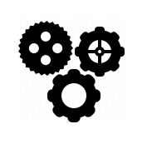 | Mimic natural movements using mechanisms such as cams, followers, levers and sliders.
Structures   | Material functional and aesthetic properties, strength and stability, stiffen and reinforce structures.
Textiles   | Fastening, sewing, decorative and functional fabric techniques including cross stitch, blanket stitch and appliqué
Electrical systems   | Operational series circuits, circuit components, circuit diagrams and symbols, combined to create various electrical products.
Digital world   | Program products to monitor and control, develop designs and virtual models using 2D and 3D CAD software.

Implementation (how we teach our curriculum)
Curriculum - The school’s curriculum is arranged so that Years 1 to 6 will have three half-term units per academic year – Autumn, Spring and Summer. Units are linked to the school’s curriculum map as much as possible. E.g., Year 1 children use textiles to make puppets linked to their history topic, Toys past and present. In EYFS, the children use Design and Technology.
Modelling – Teachers will use a variety of teaching methods to engage pupils, including demonstrations, group work, and independent tasks. Practical skills will be taught through a combination of teacher-led instruction and pupil experimentation. Children will watch the teacher demonstrate various skills and techniques using both a visualizer and hands-on methods, which will enhance their understanding. They will also view videos from Art and Design specialists that align with the lesson objectives, providing additional insights and inspiration to enrich their learning experience.
Vocabulary – In every session, children must use the specific language that is associated with that lesson or unit. When teaching, children will hear key vocabulary and its context.
Inclusion – Design Technology is for every child. Every child will be present and will be supported at their level. There will be a natural range of abilities, so positive encouragement, appropriate resources and a whole-class support approach are paramount.
Analysis – Children will analyse the works of many artists. They will make connections between the discrete skills taught and the real artwork or technology they are examining. This further deepens their understanding of the formal element in a broader range.
Sketchbooks – These will have many uses. It is a resource where children will practise specific skills and techniques using a variety of materials. Children will stick completed work to build their personal portfolio of what they have learnt this year. The child’s progression will be observed over time. When taking part in discussions during book studies, children will use their sketchbooks to talk freely about work they are proud of and what they have learnt.
Design for purpose – A key aspect of creating is making choices. When making choices, children will have the opportunity to give reasons for their decisions regarding materials, techniques, etc.
Evaluation – Looking at and discussing their own work gives children the opportunity to reflect, assess and improve their own work as well as others. Encouraging children to do this by using key vocabulary further deepens their understanding of design and technology. Teachers will model how to evaluate a piece of work, encouraging children to do likewise.
Impact
Picture building – The Subject Lead will carry this out to assess the impact of the school’s planned curriculum. This will consist of:
- Pupil Book Study: Involves looking at children’s sketchbooks. Children will have the opportunity to share work they are proud of by giving reasons why. Teachers can ask children about what they have learned, so the sketchbooks will act as prompts to support them.

- Learning observations/walks: To make sure the intended curriculum is taught, and to offer help, if needed, to any teacher.
Retrieval – At the start of each session, short reminders will help refresh and support children’s understanding of subject-specific vocabulary, especially if it is linked to the session.
Knowledge catcher – These are short picture questions that can be used at the start or end of a unit. If used at the beginning, it gives the teacher an idea of how much the children know before the material is taught.
Analysis – Teachers will gauge how easily and effectively children talk when analysing artists’ work, using vocabulary aligned with the 7 formal elements. Will the children remember the definitions of each; will they need support in using it in context; and can the children give plausible reasons when comparing artists’ work to that of their own.
Evaluating – Children need to express positively and constructively on their own work. Children will write what needs improvement and what they like about their artwork.
Quizzes – At the end of each unit, children can take part in a short multiple-choice quiz to show what they have learnt.

