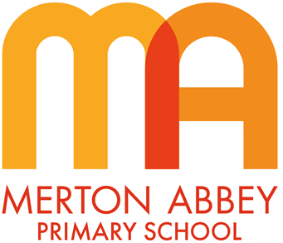
R.E. Curriculum Map 2025-2026
Our inclusive R.E. curriculum has been designed around the following school curriculum aims:
 | 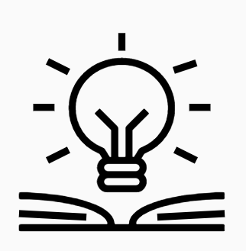 |  | 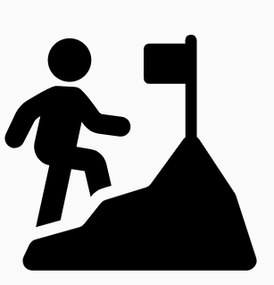 | 
Inspiring joy for learning | Knowledge rich | Reading at the heart | Challenge for all | Holistic approach

During the course of our religious education curriculum, our children will also develop the following disciplinary knowledge:
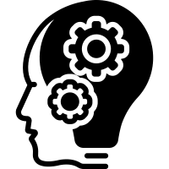 |  |  |  | 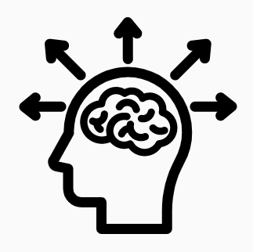
Understanding | Respect | Comparison | Appreciation | Interpretations

Merton Abbey Primary School – R.E. Curriculum Overview
Term | Autumn 1 | Autumn 2 | Spring 1 | Spring 2 | Summer 1 | Summer 2
Nursery and Reception
Unit of work | Topic Focus –  Me and my family  R.E. Focus –  We are special | Topic Focus –  Celebrations  R.E. Focus –  Special times | Topic Focus –  Food  R.E. Focus –  Special things | Topic Focus –  Plants and growth  R.E. Focus –  Our wonderful world | Topic Focus –  Animals  R.E. Focus –  Special stories | Topic Focus –  South Wimbledon (People who help us)  R.E. Focus –  Special places
Year 1
Unit of work | Belonging | Festivals | The Christian Bible 1 | Islam 1 | The Church | Creation
Year 2
Unit of work | Sacred Writings | Christian Festivals | Islam 2 | The Christian Bible 2 | Christian Faith and Values | Places of Worship
Year 3
Unit of work | Symbols in Religion | The Christian Bible | Judaism | Living Right | Islam | The Church
Year 4
Unit of work | Belonging and identity | Jesus - His early life and teachings | Birth Ceremonies | Living Right | Creation and God | Hinduism
Year 5
Unit of work | The Bible as a Holy Book for Christians | Islam | Judaism | Christian Denominations | What is faith and what difference does it make? | The Christian Way  of Life – 1
Year 6
Unit of work | Faith and the Arts | The Christian Way  of Life – 2 | Hinduism:  Worship, Celebrations  and Values | Jesus his later life and passion | Marriage | Death and Loss

